**1.INTRODUCTION**

**1.1) PROJECT PROFILE**

**1.1) PROJECT PROFILE**

|  |  |
| --- | --- |
| Project Title | Marriage Junction |
| Developers | 1. **Chopada Rinkesh M.** 2. **Kakadiya Khushal H.** |
| Development Tools | **PhpStrome 2016.2.1, Sublime text 3** |
| Language | **PHP 7.0, JavaScript, Jquery** |
| Framework | **Codeigniter** |
| Development Platform | **Windows10** |
| Documentation Tools | **Microsoft Office2010,** [**www.Draw.io**](http://www.Draw.io)**,** [**www.erdpluse**](http://www.erdpluse)**,**  **MS Visio** |
| Internal Guide | **Asst.Prof. Ragini B. Prasad** |
| Project Duration | **4 Months** |
| Submitted To | **Sutex Bank College Of Computer Applications & Science** |

**2. ENVERONMENT DESCRIPTION**

**2.1) Hardware And Software Requirements**

**2.2) Technology Use**

**2.1) Hardware And Software Requirements**

The Efficient Hardware And Software Configuration Requires To Run The System Is As Suggest Below. The Configuration Suggested Is For Better Performance. Same Functionality Or Higher Configuration Will Always Better.

|  |  |
| --- | --- |
| Resource | Description |
| Operating System | Windows OS,ubuntu |
| Browser | Google Chrome, Mozilla Firefox, UC Browser |
| Database | MySQLi |
| Server | WampServer 2.0 |
| PHP Version | 7.0 |
| Microprocessor | Any But Latest Is Good For Performance ,intel CORE i3 |
| Memory | 4 GB or Higher |
| Hard Disk Space | 500 GB |
| Internet Connection | As the website is online working can’t be used as Offline source. |

**2.2) TECHNOLOGY USE**

|  |  |
| --- | --- |
| Resource | Description |
| Core Technology | PHP 7.0 , MYSQL |
| Documentation Tool | MS-Visio, MS Power Point, MS Word, ERDPlus |
| Extra Technology | Jquery, JavaScript, Ajax, CSS. |

* **What is PHP?**

PHP, which stands for “Hypertext Preprocessor”, is a server-side; HTML embedded scripting language used to create dynamic Web pages.

Much of its syntax is borrowed from C, java and Perl with some unique features thrown in. The goal of the language is to allow web developers to write dynamically generated pages quickly.

In an **HTML** page, PHP code is enclosed within special **PHP** tags. When a visitor opens the page, the server processes the **PHP** code and then sends the output (not the **PHP** code itself) to the visitor’s browser. It means that, unlike **JavaScript**, you don’t have to worry that someone can steal your PHP script.

* **What do PHP code look like?**

PHP is a rather simple language. Much of its syntax is borrowed from C expects for dealing with the types of variables. You don’t need to think of the types of variables at all – you just work with their values, not their types. And you don’t have to declare variables before you use them.

* **Basic Syntax**
* **File Name**:

You should save your file with the extension .php(earlier versions used the extensions .php3 and .phtml).

* **Comments**:

// this comment extends to the end of the line.

/* this is

A multi-line

Comments */

* **Escaping from HTML:**

A PHP code block starts with “<?php” and ends with “?>”. A PHP code block can be placed anywhere in the HTML document.

* **Instruction separation:**

Each separate instruction must end with a semicolon. The PHP closing tag (?>) also implies the end of the instruction.

* PHP files have a file extension of

“.php”

“.php3” or

“.phtml”

* **What can PHP Do?**
* Anything PHP is mainly focused on server-side scripting, so you can do anything any other CGI program can do, such as collect from data, generate dynamic page content, or send and receive cookies. But PHP can do much more.
* There are three main areas where PHP scripts are used.
* Server-side scripting. This is the most traditional and main target field for PHP. You need three things to make this work. The PHP parser (CGI or server module), a web server and a web browser. You need to run the web server, with a connected PHP installation. You can access the PHP program output with a web browser, viewing the PHP page through the server. All these can run on your home machine if you are just experimenting with PHP programming.
* Command line scripting. You can make a PHP script to run it without any server or browser. You only need the PHP parser to use it this way.
* Writing desktop application. PHP is probably not the very best language to create a desktop application with a graphical user interface, but if you know PHP very well, and would like to use some advanced PHP features in your client-side applications you can also use PHP-GTK to write such programs. You also have the ability to write cross-platform applications this way. PHP-GTK is an extension to PHP, not available in the main distribution
* **PHP Security**
* PHP is a powerful language and the interpreter, whether included in a web server as a module or executed as a separate CGL binary, is able to access files, execute commands s open network connections on the server.
* These properties make anything run on a web server insecure by default.
* PHP is designed specifically to be a more secure language for writing CGI programs than Perl or C, and with correct selection of compile-time and runtime configuration options, and proper coding practices, it can give you exactly the combination of freedom and security you need.
* **MYSQL**

1. **Scalability and Flexibility**

* The MYSQL database server provides the ultimate in scalability, spoofing the capacity to handle deeply embedded applications with a footprint of only 1 MB to running massive data warehouses holding terabytes of information. Platform flexibility is a stalwart features of MYSQL with all flavors of Linux , UNIX , and Windows being supported.

1. **High Performance**

* A unique storage-engine architecture allows database professionals to configure the MYSQL database server specifically for particular applications, with the end result being amazing performance results. Whether the intended application is a high-speed transactional processing system or a high-volume web site that services a billion queries a day, MYSQL can meet the most demanding performance expectations of any system. With high-speed load utilities, distinctive memory caches full text indexes, and other performance-enhancing mechanisms, MYSQL offers all the right ammunition for today’s critical business systems.

1. **High Availability**

* Rock-solid reliability and constant availability are hallmarks of MYSQL, with customers relying on MYSQL to guarantee around-the-clock uptime. MYSQL offers a variety of high-availability options from high-speed master/slave replication configurations, to specialized cluster servers offering unique high-availability solution for the MYSQL database server.

1. **Robust Transactional Support**

* MYSQL offers one of the most powerful transactional database engines on the market. Features include complete ACID (atomic, consistent, isolated, durable) transaction support, unlimited row-level locking, distributed transaction capability and multi-version transaction support where readers never block writers and vice-versa. Full data integrity is also assured through server-enforced referential integrity, specialized transaction isolation levels, and instant deadlock detection.

1. **Web and Data Warehouse Strength**

* MYSQL is the de-facto standard for high-traffic web sites because of its high-performance query engine, tremendously fast data inserts capability, full text searches. These same strengths also apply to data warehousing environment where MYSQL scales up into the terabytes range for either single servers or scale-out architectures. Other features like main memory tables, B-tree and hash indexes, and compressed archive tables that reduce storage requirements by up to eight-percent make MYSQL a strong standout for both web and business intelligence applications.

1. **Strong Data Protection**

* Because guarding the data assets of corporation is the number one job of database professionals, MYSQL offers exceptional security features that ensure absolute data protection. In terms of database authentication, MYSQL provides powerful mechanisms for ensuring only authorized users have entry to the database server, with the ability to block users down to the client machine level being possible. SSH and SSL support are also provided to ensure safe and secure connections. A granular object privilege framework is present so that users only see the data they should, and powerful data encryption and decryption functions ensure that sensitive data is protected from unauthorized viewing. Finally, backup and recovery utilities provided through MYSQL and third party software vendors allow for complete logical and physical backup as well as full and point-in-time recovery.

1. **Comprehensive Application Development**

* One of the reasons MYSQL is the world’s most popular open source database is that it provides comprehensive support for every application development need. Within the database, support can be found for stored procedures, triggers, functions, views, cursors, ANSI-standard SQL, and more. For embedded applications, plug-in libraries are available to embed MYSQL database support into nearly any application. MYSQL also provides connectors and drivers (ODBC, JDBC, etc.) that allow all forms of application to make use of MYSQL as a preferred data management server. It doesn’t matter if it’s PHP, Perl, Java, Visual Basic, or .NET, MYSQL offers application developers everything they need to be successful in building database –driven information systems.
* **Apache Server**
* Apache is developed and maintained by an open community of developers under the auspices of the Apache SOT v. •arc foundation.

1. **What is the apache server foundation?**

* The Apache Software Foundation (ASF) is a non-profit 50t (cH3) corporation, incorporated in Delaware, CSA, in June of 1999. The A.SF is a natural outgrowth of The Apache Group, a group of individuals that was initially formed in 1995 to develop the Apache HTTP Server.

1. **Features of Apache Server**

* Apache supports a variety of features, many implemented as compiled modules which extend the core functionality. These can range from server-side programming language support to authentication schemes.
* Some common language interfaces support Perl, Python, TCI, and PtIP. Popular authentication modules include mod access, mod auth, mod digest, and mod auth digest, the successor to mod digest.
* **Performance of Apache Server**
* Although the main design goal of Apache is not to be the “fastest “web server, Apache does have performance comparable to other “high-performance” web servers.
* Instead of implementing a single architecture, Apache provides a variety of Multiprocessing Modules (MPMs) which allow Apache to run in a progress based hybrid (process and thread) or event-hybrid mode, to better match the demands of each particular infrastructure.
* The Apache version considered by the Apache foundation as providing high-performances is the multi-threaded version which mixes the use of several processes and several threads per process
* **What is PHP Storm?**
* PhpStorm is an Integrated Development Environment (IDE) designed specifically to facilitate the development of Internet applications written in PHP. Its main features can be split into the following categories:
* Ê Navigation Ê Editing and re-factorization Ê Files synchronization (deployment) Ê VCS Ê Debugging
* Modern web applications consist of many files, libraries, modules, and classes stored in nested folders. PhpStorm will help you to navigate through all of them. Opened files are presented on tabs; you can switch them with mouse and keyboard shortcuts. Three controls: Project view, Framework MVC Structure, and Favorites are very useful when selecting files to be opened. Project view presents a tree-like control with folders and files; Framework MVC Structure presents the project organized into controllers and view. The last control, Favorites, contains labeled groups of files. Each group can consist of arbitrary files and thus you can create easily accessible sets of files stored in many different projects' folders
* **Features of PHP Storm**

1. **PHP Code Editor**

* The IDE provides smart code completion, syntax highlighting, extended code formatting configuration, on-the-fly error checking, code folding, supports language mixtures and more. Automated refactoring that treat your code with care, helping to make global project settings easily and safely.
* **Smart PHP Code Editor**

The IDE provides smart code compilation, syntax highlighting, extended code configuration on-the-fly error checking, code supports language natures and more. Automated attracts (At that treat your code with care, helping to make global project Settings easily and safely.

* **Code Quality Analysis**

Hundreds of code inspections verify -ycu type and inspect the whole project for possible errors or code smelts. Quick-ñæs for most Inspections make it easy to fix or improve the code

* **Easy Code Navigation & Search**

You get around your code more effetely and save time when with large projects: Jump to a method function or definition in just one click or search for Its usages.

1. **Debugging , Testing and Profiling**

Phpstorm provides powerful built in tools for debugging, testing and profiling your application.

* **Debugging**

Zero configuration debugging makes it really easy to debug your PHP application. Besides PHPStrom provides numerous options for debugging your PHP code with visual debugger , so you can inspect variable and user defined watches, set breakpoints and evolutions are an expressions in runtime, debug remote applications. Debug a page in multiple sessions simultaneously, and more.

* **TESTING**

You can profile your applications with Debug or send Debugger and check aggregated reports in PHPStrom.

# HTML/CSS/JavaScript Edition

# PhpStorm include all the features of Web Storm related to HTML, CSS and JavaScript.

* **HTML and CSS Editor**

All the cutting edge web development technologies are supported including HTML5, CSS, SASS, SCSS, LESS, Coffee Script etc.

* **JavaScript Editor**

The smartest JavaScript editor is bundled with the IDE , offering code completion , validation and quick fixes , refactoring, JavaScript debugging and unit testing , support for JavaScript framework, and more.

* **New Technologies**

Phpstorm provides a streamlined experience for the full development cycle with new language such as Typescipt, CoffeeScript, and Dart.

1. **Development Environment**

Phpstorm is built on top of the open source Intel J Platform, which we at Jet Brains have been developing and perfecting for over 15 years. Enjoy the fine-tuned, highly customizable experience it provides to fit your development workflow.

* **VCS**

Phpstorm provides a unified UI for working with many popular version control system , ensuring a consistent user experience across git, GitHub, SVN .

* **Databases & SQL**

PhpStorm provide tools and code assistance features for working with databases and SQL in your project. Connect to database edit schemas and table data, run queries, and even analyze schemas with UML diagrams SQL code can be injected to other languages or edited in SQL editor, with syntax highlighting, smart code completion, on the fly code analysis, code formatting and navigation available.

* **Other Features**

Perform many routine tasks right from the IDE with support for vagrant support, Docked, Compose, and more.

* **Codeigniter**

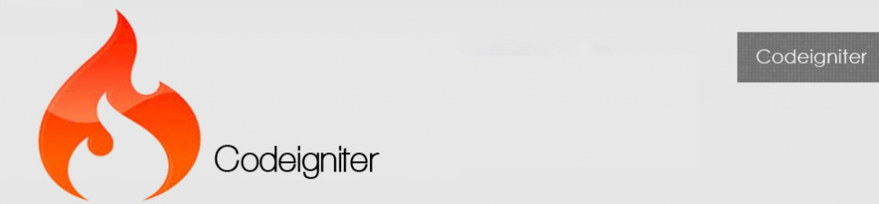

* Release Date: **Jan 09, 2017**
* CodeIgniter is an open source rapid development web application framework, for use in building dynamic web sites with PHP. The first public version of Codeigniter was released on February 28, 2006, and the latest stable version 3.1.3 was released January 09, 2017.
* CodeIgniter is loosely based on the popular Model-View-Controller development pattern. While controller classes are a necessary part of development under CodeIgniter, models and views are optional.
* CodeIgniter is most often noted for its speed when compared to other PHP frameworks. In a critical take on PHP frameworks in general, PHP creator [Rasmus Lerdorf](https://en.wikipedia.org/wiki/Rasmus_Lerdorf" \o "Rasmus Lerdorf) spoke at [frOSCon](https://en.wikipedia.org/wiki/Bonn-Rhein-Sieg_University_of_Applied_Sciences_(BRSU)" \l "FrOSCon" \o "Bonn-Rhein-Sieg University of Applied Sciences (BRSU)) in August 2008, noting that he liked CodeIgniter "because it is faster, lighter and the least like a framework"
* On July 9, 2013, **EllisLab** announced that it was seeking a new owner for CodeIgniter, citing a lack of resources to give the framework the attention they felt it deserved. On October 6, 2014, Ellis Lab announced that CodeIgniter would continue development under the stewardship of the British Columbia Institute of Technology.
* **Features of Codeigniter**
* Some of the important features of CodeIgniter are listed below –
* Model-View-Controller Based System
* Extremely Light Weight
* Full Featured database classes with support for several platforms.
* Query Builder Database Support
* Form and Data Validation
* Security and XSS Filtering
* Session Management
* Email Sending Class. Supports Attachments, HTML/Text email, multiple protocols (sendmail, SMTP, and Mail) and more.
* Image Manipulation Library (cropping, resizing, rotating, etc.). Supports GD, ImageMagick, and NetPBM
* File Uploading Class
* FTP Class
* Localization
* Pagination
* Data Encryption
* Benchmarking
* Full Page Caching
* Error Logging
* Application Profiling
* Calendaring Class
* User Agent Class
* Zip Encoding Class
* Template Engine Class
* Trackback Class
* XML-RPC Library
* Unit Testing Class Search-engine Friendly URLs
* Flexible URI Routing
* Support for Hooks and Class Extensions
* Large library of “helper” functions

**3.EXISTING SYSTEM**

**3.1) System Components**

**3.2) DRAWBACKS OF EXISTING SYSTEM**

**3.1) System Components**

In Each and every system, there is a particular system component through the system are running till now. The existing system can be any type, they can kept in either maintain in traditional manual system or can be maintained using computerize system . But after some time is need of implementation to make our organization work in more and advanced way and can completed with the existing system of others.

The existing or in other word the current system of our organization is completely manually.

1. Admin
2. Registred user
3. Visiter

**Definition**

The matrimonial system is make easy way to find life partner and show all the detail of lifepartner then user can find their partner very easily. This system provide many services like chat with members, select membership plan,update profile and etc.

* With design of marriagejunction.com any user can registeras free member.
* This system provide the information about user’s all personal details.
* Design of marriagejunction.com fulfilled this objective by providing many facility to their member.
* Design of marriagejunction.com is one matrimonial website, so the objective of any matrimonial website is to provide easy and perfect way to find perfect life partner for it’s members.
* This system is satisfied a user need through special membership planning.

**Advantages:**

* One time of registration for members-free.
* This site provides information to visit website for user about different searching facility.
* This system is easy to understand and user friendly.
* Facility to uploading profile photo.
* Chat facility
* Forgot password through E-mail.
* Profile verification through SMS.

**Features:**

* **Efficient project and task management**

At the heart of the system the ever moving task that flow smoothly at various levels, is managed very efficiently. Every task can be placed into the correct project or program or recorded as ad-hoc work. Task and project can be quickly sorted and selected and searched. Permission among other things, allow you to manage the employees and their access. Each employee can easily and securely see the status of every task and project in their queue and can quickly update the important details asa work proceeds- more efficiently than ever.

* **Email Notification:**

To keep all user informed, the system sends simple, easy-to-understand email regarding their username and password authentication information.

**3.2) DRAWBACKS OF EXISTING SYSTEM**

* We Are Going To Enhance The Paypal System For Online Transaction So That Customer Has No Worried About The Payment System He Or She Has Just Information About The Credit Card And Electronic Payment Cards.
* When will found any matches at that time notify to user his/her match details by SMS ,Email.

**4) SYSTEM PLANNING**

**4.1) Feasibility Study**

**4.2) Requirement Analysis And Data Gathering Study**

**4.1) Feasibility Study**

* Technical Feasibility

This Website Does Require That Much Of Higher & Advanced Technology. It Requires Database Interaction And It Also Requires To Be Accessed Via Web Or Internet. This Can Be Easily Done. Also These Should Be A Facility Of Metrimonial And Also For The Particular user On Line. It Must Be Developed Within The Three Months Of Period Excluding The Time Period For The Testing , Validation And Verification. Thus It Seems That The Project Is Technically Feasible To Do.

* Economical Feasibility

In This Project, We Will Require To Have A Internet Connection For Better Online Website. Such At The Developer End It Needs The Good Server With High Capacity Of RAM And CPU Processors So Can It Can Handle Lots Of Members At Time Online Communications, But As It Will Be Web-Enabled We Do Not Have Any Extra Cost Of Setting Up A Network. This Is Also Feasible Economically.

* Operational Feasibility

The New System Can Be Beneficial Only If It Satisfies The Organization Requirements, In Such A Way That Resource Utilization And Optimum Outcome Is Justified. A New System Should Not Only Be Robust But Should Also Be Able To Work Simultaneously With Other Systems. Operational Feasibility Means That New System Should Not Affect Any Existing System During The Development Phase Or Even In The Implementation Phase. Following Are Some Points Underlying The Operational Feasibility Of The System- As The Development Proceeded Many Doubts Got Cleared Out.

Our Project Guide – Mrs. Ragini B. Prasad Guided Us To Take Proper Care And Check For The Operational Feasibility Of The System.Efforts Were Made To Optimize The Human Efforts In Data Collection, Storage, Retrieval, Security And Presentation.

**4.2) REQUIREMENT ANALYSIS AND DATA GATHERING**

* Requirement Gathering
  + Before Developing An Elegant Software, Best Way To Identify Basic Needs And Functionality Is To Take Interview Of Director And Management Who Are Working In That Specific Area Addressed By Proposed Application.
  + For Gathering Basic Needs And Functionalities, We Had Meeting With Chairman Personally To Understand Required Functionalities, Also Noted Down Some Useful Features To Be Included.
  + By Analyzing The Information We Understand Following Process Requirement For Security System.
* Understanding The Process Of Security System
* What Type Of Forms Should Be Included ?
  + How To Manage All Forms ?
  + How To Manage Reminder Process ?
  + How To Manage Login And Logout Process ?
  + How To Know How Many Members Are Created And How Many Queries Are Generated On The Particular Day ?
  + How To Manage All Forms Linked With Each Other ?
  + How To Manage Inter-communication With Internet ?
  + How To Manage Matches ?
  + How To Manage The Bunch Of Data Of A Particular Member So That It Can Have The Security Purpose And Keep The Data Private ?
  + How To Manage All The Members Online And To Care Of Offline ?
  + How To Perform All Members Security Level And Perform A Authentication And Give Person Account To Each Member For Security Purpose ?
* Understand Different Type Of User Who Uses This Website
  + How Many Members Are Going To Use This Website ?
  + What Is The Knowledge Level Of The Member And How Does It Maintain The Shopping Criteria ?
  + Provide Authorization And Separate Their Functionality ?

**5) PROPOSED SYSTEM**

**5.1) Scope**

**5.2) Objectives**

**5.3) Constraints**

**5.4) Expected Advantages**

**5.1) SCOPE**

Marriagejunction.com is a matrimonial website which will allow users to find their perfect life partner. This website is usefull to all users which are looking for brides or grooms. In this site people have meet their lifepartner through our revolutionary matchmaking service and countless others have made some very special friends.

**5.2) OBJECTIVES**

Design of marriagejunction.com is one matrimonial website, so the main objective of any matrimonial website is to provide easy and perfect way to find perfect Life-partner.

**5.3) CONSTRAINTS**

The Constraint Associated In The Development Of Any Software System Includes Those That Are Common To All System. The Common Constraints May Include Lack Of Managerial Participation Tighter Development Schedule Etc.

Some Of The Constraints Are Listed Below With Which We Have Developed This System:

* User Mistake Can Be Turned Into The Improper Answer.
* The Common Constraints May Include Lack Of Managerial Participation Tighter Development Schedule Frequently Working For Management Etc.
* It Has Some Specification Need To Run This Software Because Is Developed In The PHP With Linux.
* Net Connection And Other Web Related Software Are Required.

**5.5) EXPECTED ADVANTAGES**

* High Security

There Is High Security Mechanism Provided By The Proposed System. No Unauthorized Person Can Make Change In The Data Those Are Stored In Website. Only Authorized Person Can Change & Also Can Make Login.

* Less Time Required

In Our Website, All The Processes Are Carried Out By Computer So Obviously It Will Require Time Than Traditional Inventory System And In That Sense, It Will Require Less Time To Complete Transactions And Can Process Data Very Fast.

* High Amount Of Accuracy

In Our Web System There Are Less Amount Of Human Activities Are Involved In That Case It Will Have Less Effect In Our Accounts. The Website Will Perform All Calculation And Manipulation Automatically; In That Case The Data That We Receive Will Be Accurate And Much More Reliable Than The Data That Generated Previously.

* Easy To Use

Online Saree Shopping Is Accessible Round The Clock. You Can Buy Whatever You Want Even At 3 A.M. In The Morning. You Can Choose From A Wider Variety Of Things Available For You To Shop Which May Not Be Available In The Local Brick And Mortar Stores. You Also Have The Benefit To Do All From The Comfort Of Your Own Home. When You Buy From Online Store You Have The Comfort To Take Your Time While Checking For The Things Of Your Choice, This Will Lead You To A Simple And Quick Way To Perform Price Comparison Unlike The Dissatisfied And Hurried Shopping You Do In The Local Stores.

**6) DETAIL PLANNING**

**6.1) Data Flow Diagram**

**6.2) Process Specification**

**6.3) Data Dictionary**

**6.1) DATA FLOW DIAGRAM**

* Data Flow Diagram :

The Data Flow Diagrams Are An Intuitive Way Of Showing How Data Is Processed By A System. The Symbols Used In The DFD For This Project Are Shown Bellow.

* Data Flow :

Following Symbol Is Used To Show Data Flow. The Data Flow Is Packet Of Data.

* Processes :

People, Procedures Or Devices That Use Or Produce Data.

* Source Or Destination Of Data :

These Are The Entities, Which Interact With The System From Outside Its Boundaries.

* Data Storage :

Here Data Are Stored Or Referenced Process In The System.

In The DFD Diagram We Define The Flow Of Data And How The System Data Flow Managed By Grouping The Data With The Entity Relationship. In This Way We Find Out The Need Of The System And Managed It In Particular Way By Which We Can Easily Access With The System.

By The Use Of DFD Diagram All The Complete Data Flow Is Understood By The System Analysis. Here In Our DFD There Is A Once The Patient Is Going For Treatment The Management Of Hospital First Inform The Patient That Which Kind Of Treatment Is Available And What Kind Of Task Is Performed By The Person And Which Kind Of Function Should Be Implemented By The Management Person Who Is Managing.

* 0 Level Diagram ( Context Diagram ) :



* 1st Level Of User Diagram :



* 1st Level Of Admin Diagram :



* 2nd Level User Diagram :

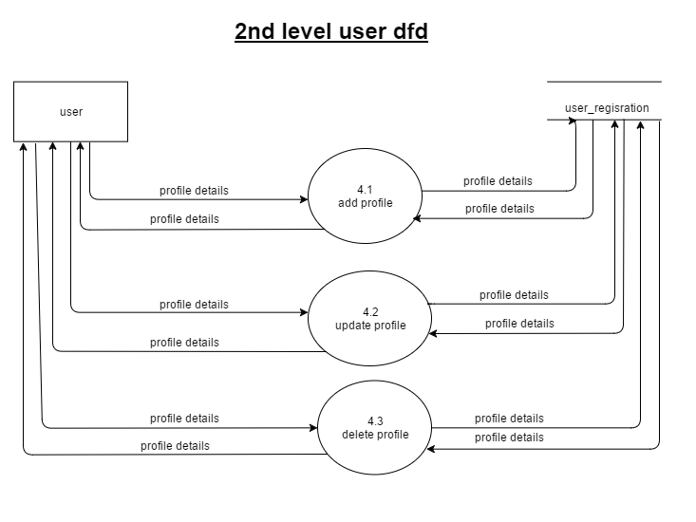

* 2nd Level Admin Diagram :



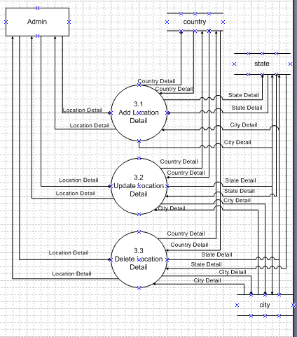

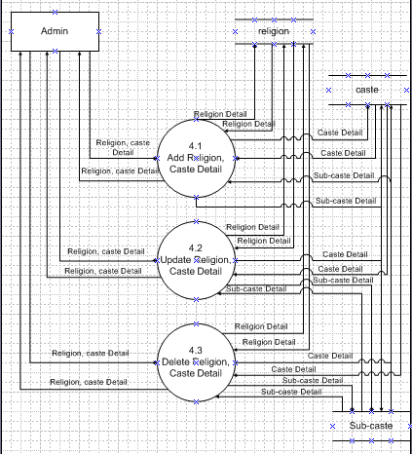

**6.2) PROCESS SPECIFICATION**

* Registration Process :

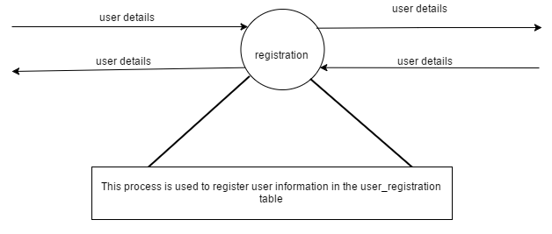

* Login Process :

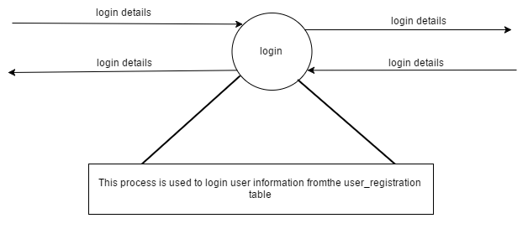

* Find Matches Process :

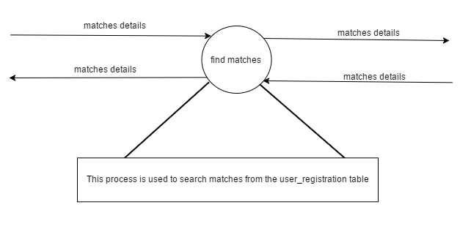

* Add Profile Process :

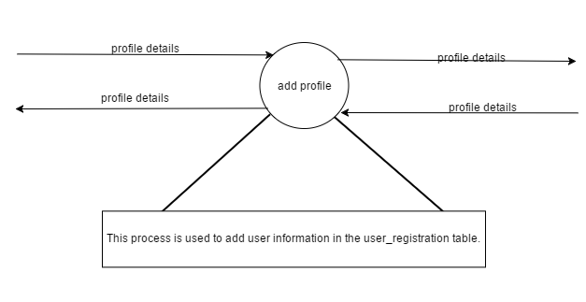

* Update Profile Process :

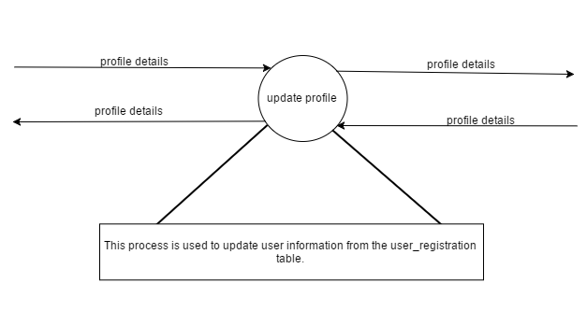

* Delete Profile Process :

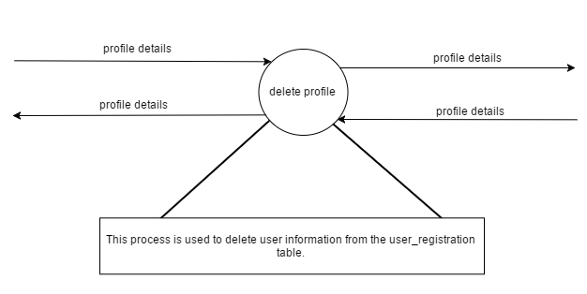

* Live Chat Process

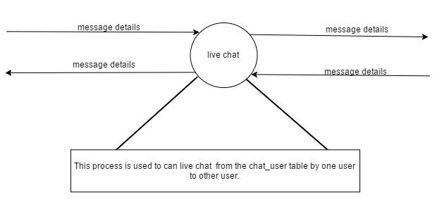

* Membership Plan Process :

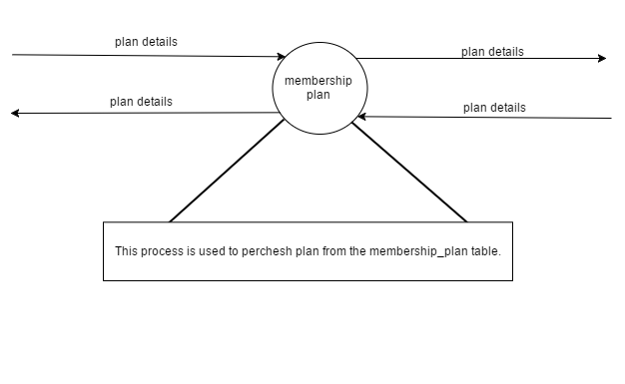

* Login Process :

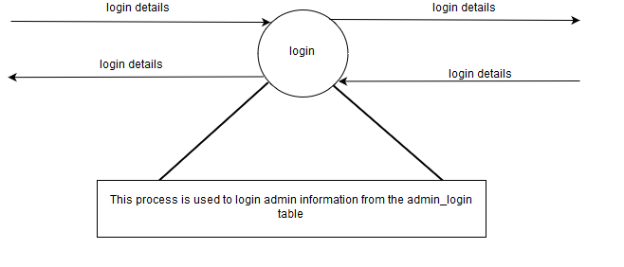

* View User Profile Process :

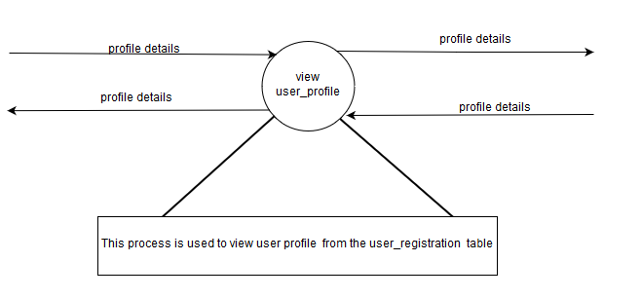

* Block User Profile Process :

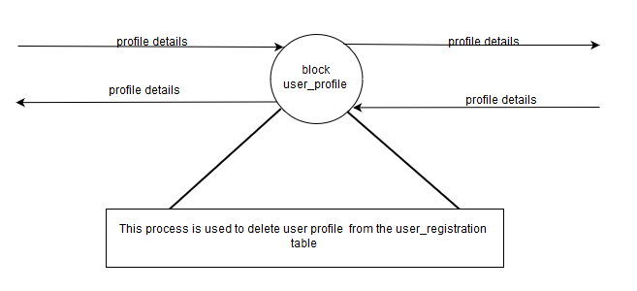

* Add Location Process :

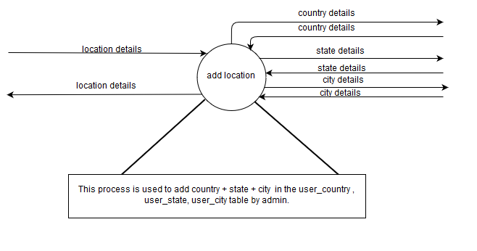

* Update Location Process :

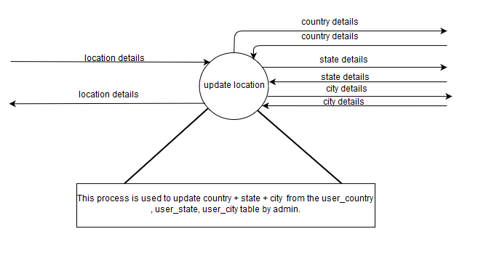

* Delete Location Process :

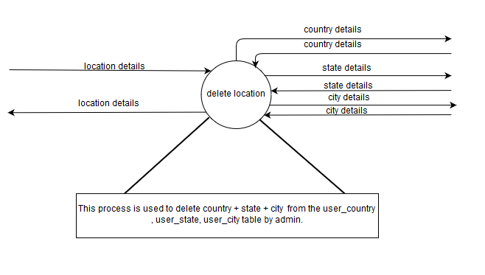

* Add Religion,Caste Detail :

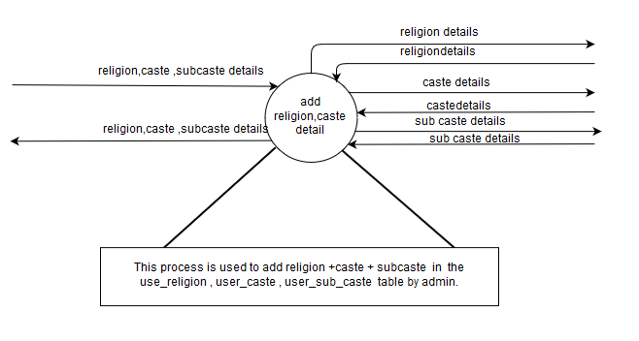 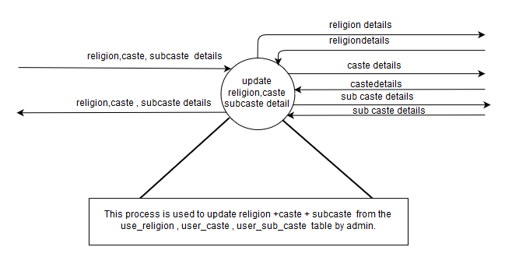

* Delete Religion, Caste Details :

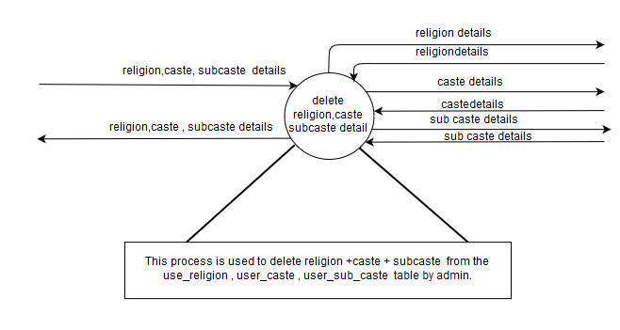

* Add Membership Plan Process :

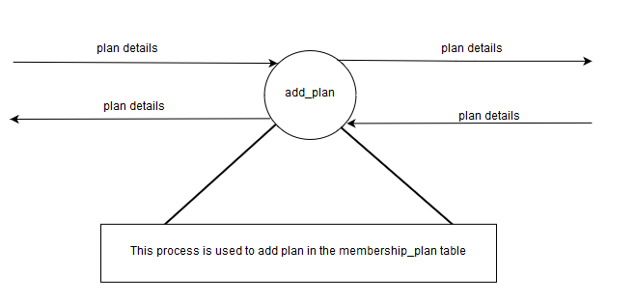

* Update Membership Plan Process :

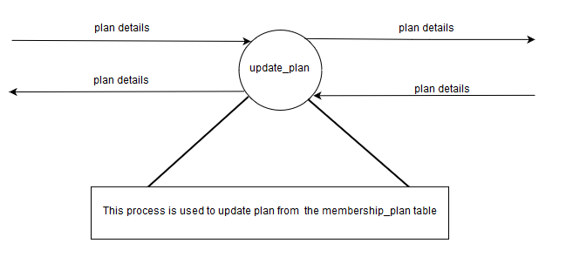

* Block Membership Plan Process :

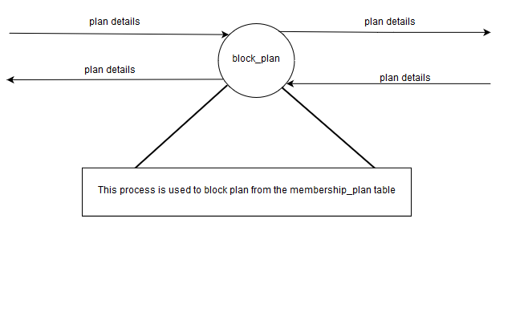

**6.3) DATA DICTIONARY**

User:

* User Registration Details :

|  |  |
| --- | --- |
| Name | user details |
| Alias name |  |
| Where used | registration |
| How used | Input / Output |
| Description | profile_id + user_name + user_password + name + birthdate + country + religion + gender + education_level + father_status + mother_status + body_type + diet + smoke + employee_in. |

* Login :

|  |  |
| --- | --- |
| Name | login details |
| Alias name |  |
| Where used | Registration |
| How used | Input / Output |
| Description | user_name + user_password. |

* Matches :

|  |  |
| --- | --- |
| Name | matches details |
| Alias name |  |
| Where used | find matches |
| How used | Input / Output |
| Description | To find the matches for perticular user from his/her partner preference. |

* Add Profile :

|  |  |
| --- | --- |
| Name | profile details |
| Alias name |  |
| Where used | add profile |
| How used | Input / Output |
| Description | To add profile details for perticular user in the user_registration table. |

* Update Profile :

|  |  |
| --- | --- |
| * Name | profile details |
| Alias name |  |
| Where used | update profile |
| How used | Input / Output |
| Description | To change / update profile details for perticular user from the user_registration table. |

* Delete Profile :

|  |  |
| --- | --- |
| Name | profile details |
| Alias name |  |
| Where used | delete profile |
| How used | Input / Output |
| Description | To delete profile details for perticular user from the user_registration table. |

* Message Details :

|  |  |
| --- | --- |
| Name | message details |
| Alias name |  |
| Where used | Live chat |
| How used | Input / Output |
| Description | Name + email + password + image +info + role + last_activity. |

* Plan Details :

|  |  |
| --- | --- |
| Name | plan details |
| Alias name |  |
| Where used | membership plan |
| How used | Input / Output |
| Description | when user trial day over than after he/she must select plan for continue stay on site. |

# Admin

* Admin Login :

|  |  |
| --- | --- |
| Name | login information |
| Alias name |  |
| Where used | login |
| How used | Input / Output |
| Description | admin_user_name + admin_password |

* View User Profile :

|  |  |
| --- | --- |
| Name | user profile details |
| Alias name |  |
| Where used | view user profile |
| How used | Input / Output |
| Description | Admin can view perticular user details from user_registration table. |

* Block User Profile :

|  |  |
| --- | --- |
| Name | user profile details |
| Alias name |  |
| Where used | block user profile |
| How used | Input / Output |
| Description | Admin can block perticular user from user_registration table. |

* Add Country :

|  |  |
| --- | --- |
| Name | country details |
| Alias name | location details |
| Where used | add location details |
| How used | Input / Output |
| Description | To add counrty details in the user_counrty table. |

* Update Country :

|  |  |
| --- | --- |
| Name | country details |
| Alias name | location details |
| Where used | update location details |
| How used | Input / Output |
| Description | To update country details from the user_country table. |

* Delete Country :

|  |  |
| --- | --- |
| Name | country details |
| Alias name | location details |
| Where used | delete location details |
| How used | Input / Output |
| Description | To delete country details from the user_country table. |

* Add State :

|  |  |
| --- | --- |
| Name | state details |
| Alias name | location details |
| Where used | add location details |
| How used | Input / Output |
| Description | To add state details in the user_state table. |

* Update State :

|  |  |
| --- | --- |
| Name | state details |
| Alias name | location details |
| Where used | update location details |
| How used | Input / Output |
| Description | To update state details from the user_state table. |

* Delete State :

|  |  |
| --- | --- |
| Name | state details |
| Alias name | location details |
| Where used | delete location details |
| How used | Input / Output |
| Description | To delete state details from the user_state table. |

* Add City :

|  |  |
| --- | --- |
| Name | city details |
| Alias name | location details |
| Where used | add location details |
| How used | Input / Output |
| Description | To add city details in the user_city table. |

* Update City :

|  |  |
| --- | --- |
| Name | city details |
| Alias name | location details |
| Where used | update location details |
| How used | Input / Output |
| Description | To update city details from the user_city table. |

* Delete City :

|  |  |
| --- | --- |
| Name | city details |
| Alias name | location details |
| Where used | delete location details |
| How used | Input / Output |
| Description | To delete city details from the user_city table. |

* Add Religion :

|  |  |
| --- | --- |
| Name | religion details |
| Alias name | religion , caste, subcaste details |
| Where used | Add religion , caste, subcaste details |
| How used | Input / Output |
| Description | To add religion details in the user_religion table. |

* Update Religion :

|  |  |
| --- | --- |
| Name | religion details |
| Alias name | religion , caste, subcaste details |
| Where used | update religion , caste, subcaste details |
| How used | Input / Output |
| Description | To update religion details from the user_religion table. |

* Delete Religion :

|  |  |
| --- | --- |
| Name | religion details |
| Alias name | religion , caste, subcaste details |
| Where used | delete religion , caste, subcaste details |
| How used | Input / Output |
| Description | To delete religion details from the user_religion table. |

* Add Caste :

|  |  |
| --- | --- |
| Name | caste details |
| Alias name | religion , caste, subcaste details |
| Where used | add religion , caste, subcaste details |
| How used | Input / Output |
| Description | To add caste details in the user_caste table. |

* Update Caste :

|  |  |
| --- | --- |
| Name | caste details |
| Alias name | religion , caste, subcaste details |
| Where used | update Religion , caste, subcaste details |
| How used | Input / Output |
| Description | To update caste details from the user_caste table. |

* Delete Caste :

|  |  |
| --- | --- |
| Name | caste details |
| Alias name | religion , caste, subcaste details |
| Where used | delete Religion , caste, subcaste details |
| How used | Input / Output |
| Description | To delete caste details from the user_caste table. |

* Add Subcaste :

|  |  |
| --- | --- |
| Name | subcaste details |
| Alias name | religion , caste, subcaste details |
| Where used | add religion , caste, subcaste details |
| How used | Input / Output |
| Description | To add subcaste details in the user_subcaste table. |

* Update Subcaste :

|  |  |
| --- | --- |
| Name | subcaste details |
| Alias name | religion , caste, subcaste details |
| Where used | update religion ,caste ,subcaste details |
| How used | Input / Output |
| Description | To update subcaste details from the user_subcaste table. |

* Delete Subcaste :

|  |  |
| --- | --- |
| Name | subcaste details |
| Alias name | religion ,caste, subcaste details |
| Where used | delete religion ,caste ,subcaste details |
| How used | Input / Output |
| Description | To delete subcaste details from the user_subcaste table. |

* Add Plan :

|  |  |
| --- | --- |
| Name | plan details |
| Alias name |  |
| Where used | add plan |
| How used | Input / Output |
| Description | To add plan details in the membership_plan table. |

* Update Plan :

|  |  |
| --- | --- |
| Name | plan details |
| Alias name |  |
| Where used | update plan |
| How used | Input / Output |
| Description | To update plan details from the membership_plan table. |

* Block Plan :

|  |  |
| --- | --- |
| Name | plan details |
| Alias name |  |
| Where used | block plan |
| How used | Input / Output |
| Description | To block plan details from the membership_plan table. |

**7) SYSTEM DESIGN**

**7.1) DATABASE DESIGN**

**7.2) DIRECTORY STRUCTURE**

**7.3) Input Design**

**7.4) OUTPUT DESIGN**

**7.1) DATABASE DESIGN**

## Table Name : User Registration

**Purpose : Store user information**

|  |  |  |  |
| --- | --- | --- | --- |
| **Column** | **Type** | **Null** | **Constrain** |
| profile_id | int(11) | No | Primary Key |
| user_name | varchar(255) | No |  |
| user_password | varchar(255) | No |  |
| create_profile_for | varchar(50) | No |  |
| Gender | varchar(7) | No |  |
| Name | varchar(50) | No |  |
| date_of_birth | varchar(50) | No |  |
| Religion | varchar(50) | No |  |
| mother_tongue | varchar(50) | No |  |
| Country | varchar(50) | No |  |
| tmp_password | varchar(50) | Yes | *NULL* |
| Status | varchar(50) | No | active |
| Date | Timestamp | No | CURRENT_TIMESTAMP |

## Table Name : Admin Login

**Purpose : Store the information about admin**

|  |  |  |  |
| --- | --- | --- | --- |
| **Column** | **Type** | **Null** | **Constrain** |
| admin_user_name | varchar(50) | No |  |
| admin_password | varchar(50) | No |  |

## Table Name : User_Education_info

**Purpose : Store the education details of user**

|  |  |  |  |
| --- | --- | --- | --- |
| **Column** | **Type** | **Null** | **Constaint** |
| profile_id | int(11) | No | Primary Key |
| education_level | varchar(50) | No |  |
| education_field | varchar(50) | No |  |
| employee_in | varchar(50) | No |  |
| Post | varchar(50) | No |  |
| annual_income | varchar(50) | No |  |

## Table Name : User_Basic_info

**Purpose : Store the Basic information of user**

|  |  |  |  |
| --- | --- | --- | --- |
| **Column** | **Type** | **Null** | **Constrain** |
| profile_id | int(11) | No | Primary Key |
| State | varchar(50) | No |  |
| City | varchar(50) | No |  |
| marital_status | varchar(50) | No |  |
| no_of_child | varchar(50) | No |  |
| Community | varchar(50) | No |  |
| sub-community | varchar(50) | No |  |
| regional_site | varchar(50) | No |  |

## Table Name : User_Caste

**Purpose : Store the Caste Information**

|  |  |  |  |
| --- | --- | --- | --- |
| **Column** | **Type** | **Null** | **Constrain** |
| caste_id | int(11) | No | Primary Key |
| caste_name | varchar(50) | No |  |
| religion_id | int(11) | No | Foreign Key |

## Table Name : User_Family_Detail

**Purpose : Store the Family Details of user**

|  |  |  |  |
| --- | --- | --- | --- |
| **Column** | **Type** | **Null** | **Constrain** |
| profile_id | int(11) | No | Primary Key |
| father_status | varchar(50) | No |  |
| mother_status | varchar(50) | No |  |
| no_of_brothers | int(11) | No |  |
| no_of_merried_brother | int(11) | No |  |
| no_of_sister | int(11) | No |  |
| no_of_merried_sister | int(11) | No |  |
| affluence_level | varchar(50) | No |  |

## Table Name : User_Country

**Purpose : Store the Country Details**

|  |  |  |  |
| --- | --- | --- | --- |
| **Column** | **Type** | **Null** | **Constrain** |
| country_id | int(11) | No | Primary Key |
| country_name | varchar(50) | No |  |

## Table Name : User_Lifestyle

**Purpose : Store the Lifestyle Details of user**

|  |  |  |  |
| --- | --- | --- | --- |
| **Column** | **Type** | **Null** | **Constrain** |
| profile_id | int(11) | No | Primary Key |
| Diet | varchar(50) | No |  |
| Smoke | varchar(10) | No |  |
| Drink | varchar(11) | No |  |
| Height | varchar(50) | No |  |
| body_type | varchar(11) | No |  |
| body_tone | varchar(11) | No |  |
| Mobile | bigint(20) | No |  |

## Table Name : User_City

**Purpose : Store the City Details**

|  |  |  |  |
| --- | --- | --- | --- |
| **Column** | **Type** | **Null** | **Constrain** |
| city_id | int(11) | No | Primary Key |
| city_name | varchar(50) | No |  |
| state_id | int(11) | No | Foreign Key |

## Table Name : Chat_User

**Purpose : Store the Chat Details of user**

|  |  |  |  |
| --- | --- | --- | --- |
| **Column** | **Type** | **Null** | **Constrain** |
| id | bigint(20) | No | Primary Key |
| Name | varchar(50) | No |  |
| Mail | char(64) | No |  |
| password | char(255) | No |  |
| Image | char(128) | Yes | *NULL* |
| Info | Text | Yes | *NULL* |
| Roles | char(128) | Yes | *NULL* |
| last_activity | Timestamp | No | 0000-00-00 00:00:00 |

## Table Name : User_Description

**Purpose : Store the Description of user**

|  |  |  |  |
| --- | --- | --- | --- |
| **Column** | **Type** | **Null** | **Constrain** |
| profile_id | int(11) | No | Primary Key |
| about_user | Text | No |  |
| Disability | varchar(11) | No |  |

## Table Name : Membership_Plan

**Purpose : Store the Membership Plan Details**

|  |  |  |  |
| --- | --- | --- | --- |
| **Column** | **Type** | **Null** | **Constrain** |
| plan_id | int(11) | No | Primary Key |
| plan_name | varchar(50) | No |  |
| plan_display_name | varchar(50) | No |  |
| plan_details | varchar(50) | No |  |
| no_of_contacts | int(11) | No |  |
| plan_duration | int(11) | No |  |
| plan_amount | int(11) | No |  |
| Status | varchar(10) | No |  |

## Table Name : User_Religion

**Purpose : Store the Religion Information**

|  |  |  |  |
| --- | --- | --- | --- |
| **Column** | **Type** | **Null** | **Constrain** |
| religion_id | int(11) | No | Primary Key |
| religion_name | varchar(50) | No |  |

## Table Name : User_Chat_Messsage

**Purpose : Store the Chat Messages of User**

|  |  |  |  |
| --- | --- | --- | --- |
| **Column** | **Type** | **Null** | **Constrain** |
| id | bigint(20) | No | Primary key |
| from_id | bigint(20) | No |  |
| to_id | bigint(20) | No |  |
| Body | Text | No |  |
| Datetime | Timestamp | No | CURRENT_TIMESTAMP |
| talk_id | bigint(20) | No |  |
| is_new | char(1) | No | y |
| from_user_info | Text | No |  |
| to_user_info | Text | No |  |

## Table Name : User_State

**Purpose : Store the State Information**

|  |  |  |  |
| --- | --- | --- | --- |
| **Column** | **Type** | **Null** | **Constrain** |
| state_id (Primary) | int(11) | No | Primary Key |
| state_name | varchar(50) | No |  |
| country_id | int(11) | No | Foreign key |

## Table Name : User_Sub_Caste

**Purpose : Store the Sub Caste Information**

|  |  |  |  |
| --- | --- | --- | --- |
| **Column** | **Type** | **Null** | **Constrain** |
| sub_caste_id (Primary) | int(11) | No | Primary Key |
| sub_caste_name | varchar(50) | No |  |
| caste_id | int(11) | No | Foreign Key |

## Table Name : User_Upload

**Purpose : Store the Profile Photo Of User**

|  |  |  |  |
| --- | --- | --- | --- |
| **Column** | **Type** | **Null** | **Constrain** |
| upload_id (Primary) | int(11) | No | Primary Key |
| profile_id | int(11) | No | Foreign key |
| upload_type | int(11) | No |  |
| file_name | varchar(50) | No |  |

## Table Name : Who_View_Profile

**Purpose : Store the Who View Profile of Other user**

|  |  |  |  |
| --- | --- | --- | --- |
| **Column** | **Type** | **Null** | **Constrain** |
| profile_id | int(11) | No | Primary Key |
| who_view | int(11) | No |  |

## Table Name : Visitor

**Purpose : Store the Visitor’s Details**

|  |  |  |  |
| --- | --- | --- | --- |
| **Column** | **Type** | **Null** | **Constaint** |
| visitor_id | int(50) | No | Primary Key |
| ip_address | varchar(50) | No |  |
| Os | varchar(50) | No |  |
| Browser | varchar(50) | No |  |
| Date | varchar(20) | No |  |
| Time | varchar(20) | No |  |
| Country | varchar(20) | No |  |
| State | varchar(30) | No |  |
| City | varchar(30) | No |  |
| Zipcode | int(11) | No |  |
| latitude | varchar(20) | No |  |
| longitude | varchar(20) | No |  |

**7.2) DIRECTORY STRUCTURE**

|  |  |
| --- | --- |
| PHP Files(View) | |
| Header.php | **Add_country.php** |
| Footer.php | **Add_state.php** |
| Home.php | **Add_city.php** |
| Register.php | **Admin_header.php** |
| Login.php | **Admin_home.php** |
| Changepwd.php | **Block_member.php** |
| viewed-profile.php | **Chart.php** |
| upload_profile_pic.php | **Des_caste.php** |
| About.php | **Des_city.php** |
| Matches.php | **Des_country.php** |
| Members.php | **Des_city.php** |
| Privacy.php | **Des_religion.php** |
| Search.php | **Des_state.php** |
| Update_Profile.php | **Des_subcaste.php** |
| Wizard_form.php | **Paid_member.php** |
| Add_caste.php | **Membership _plan.php** |
| Add_sub_caste.php | **Register_member.php** |
| Add_religion.php | **Visitor_member.php** |

**7.3) Input Design**

Admin Login Page

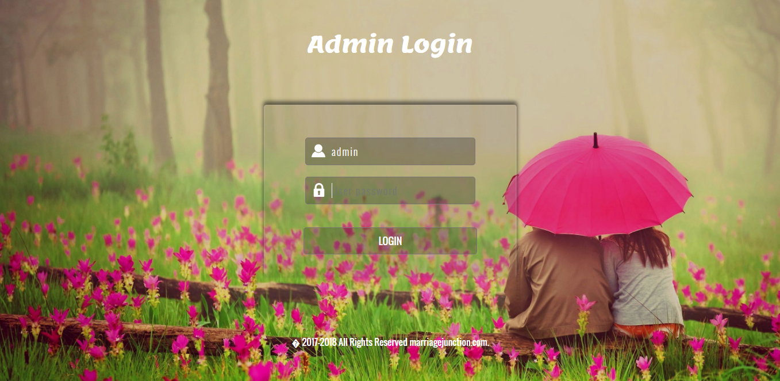

Add Membership Plan

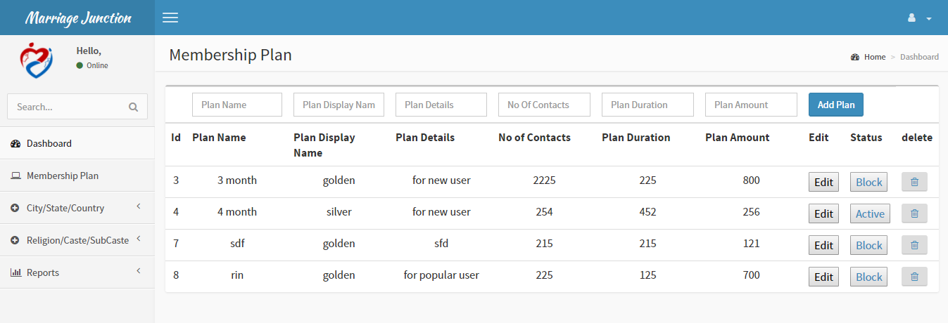

Add Religion Details

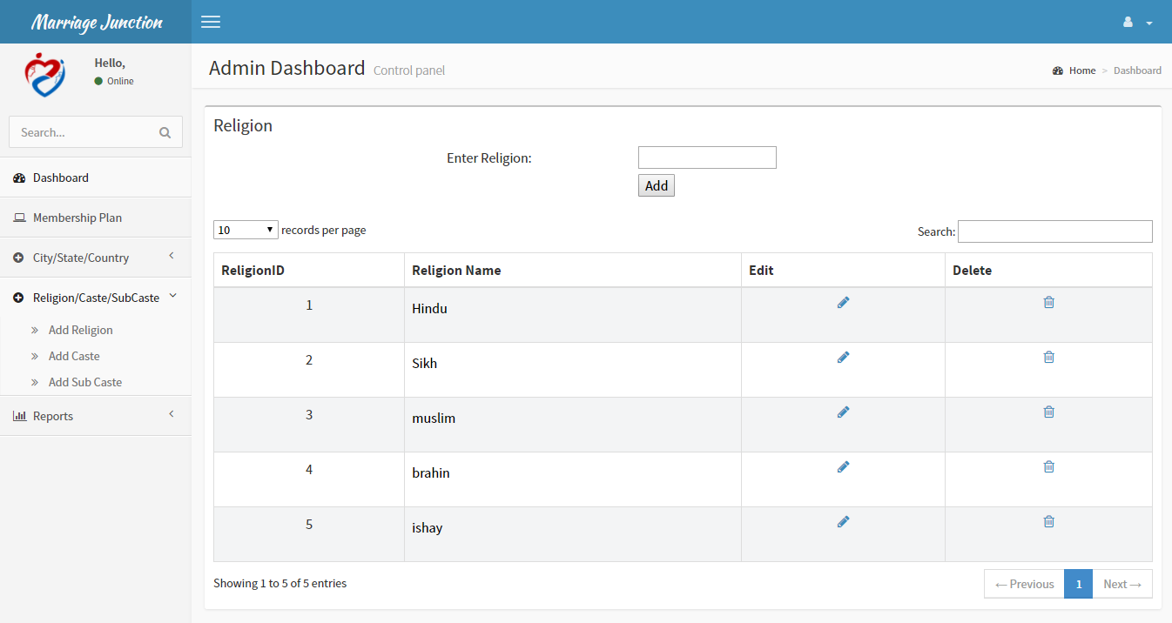

Update City Details

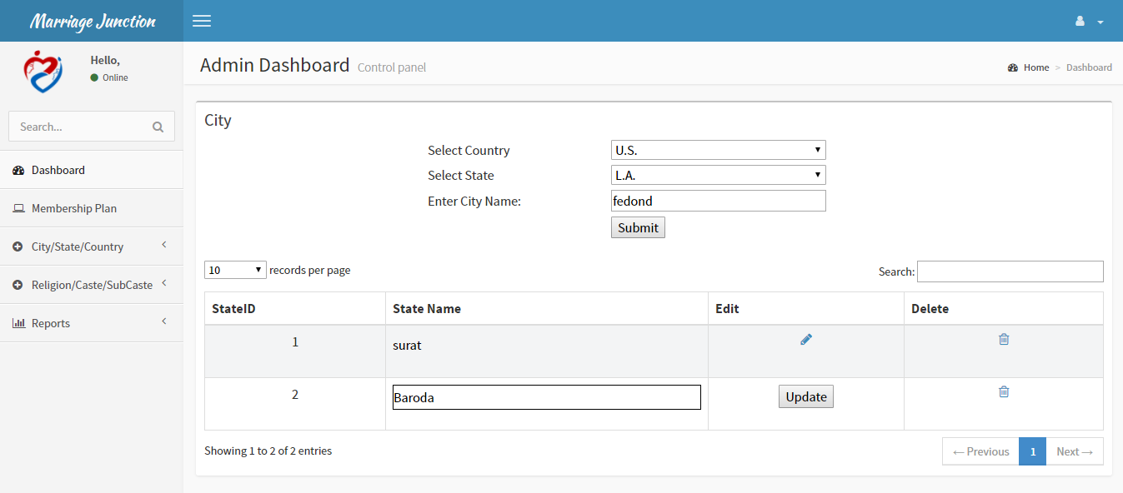

Home Page

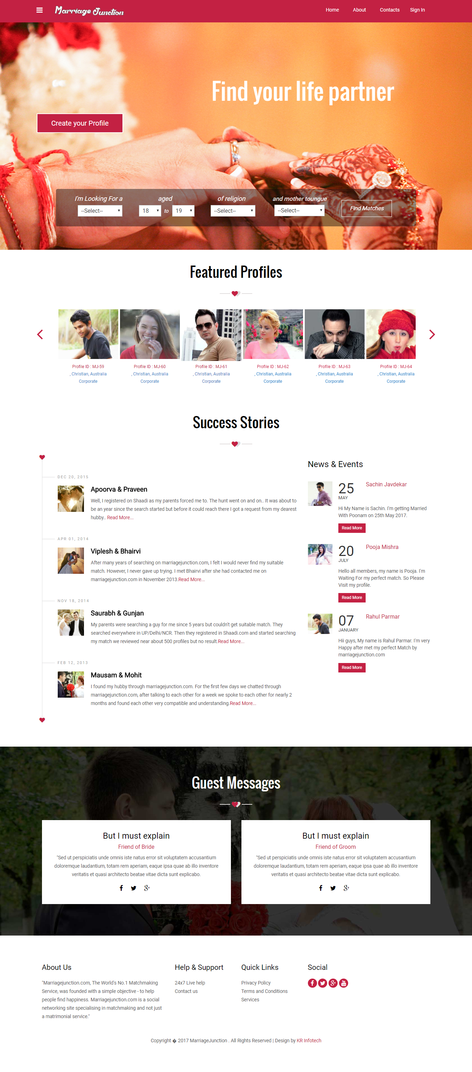

Login

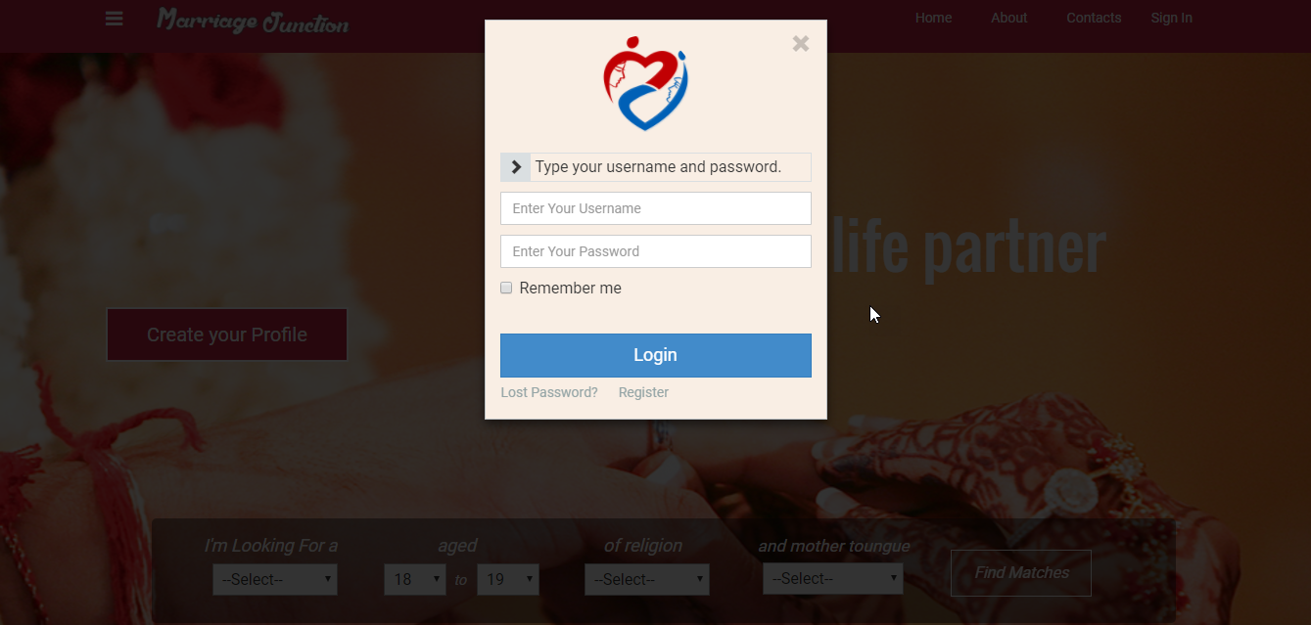

Registration

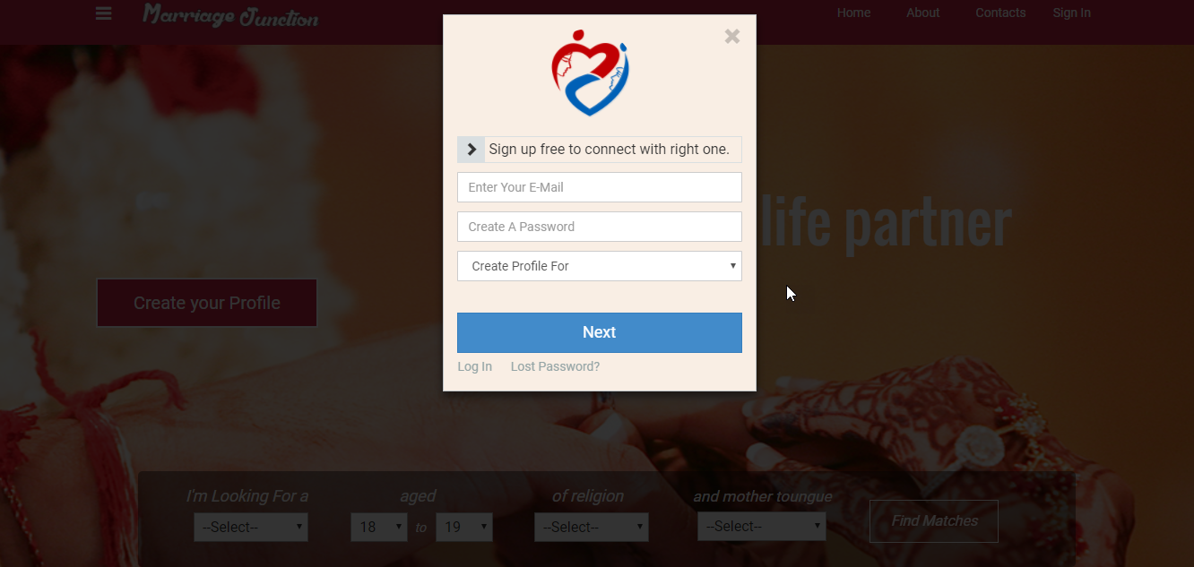

Registration(Contd.)

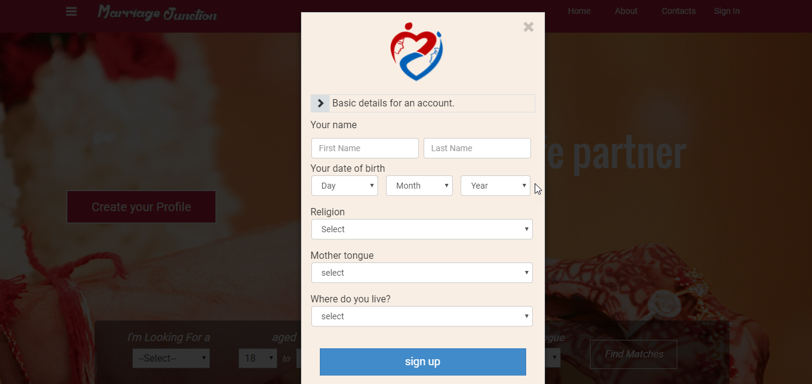

Wizard Form

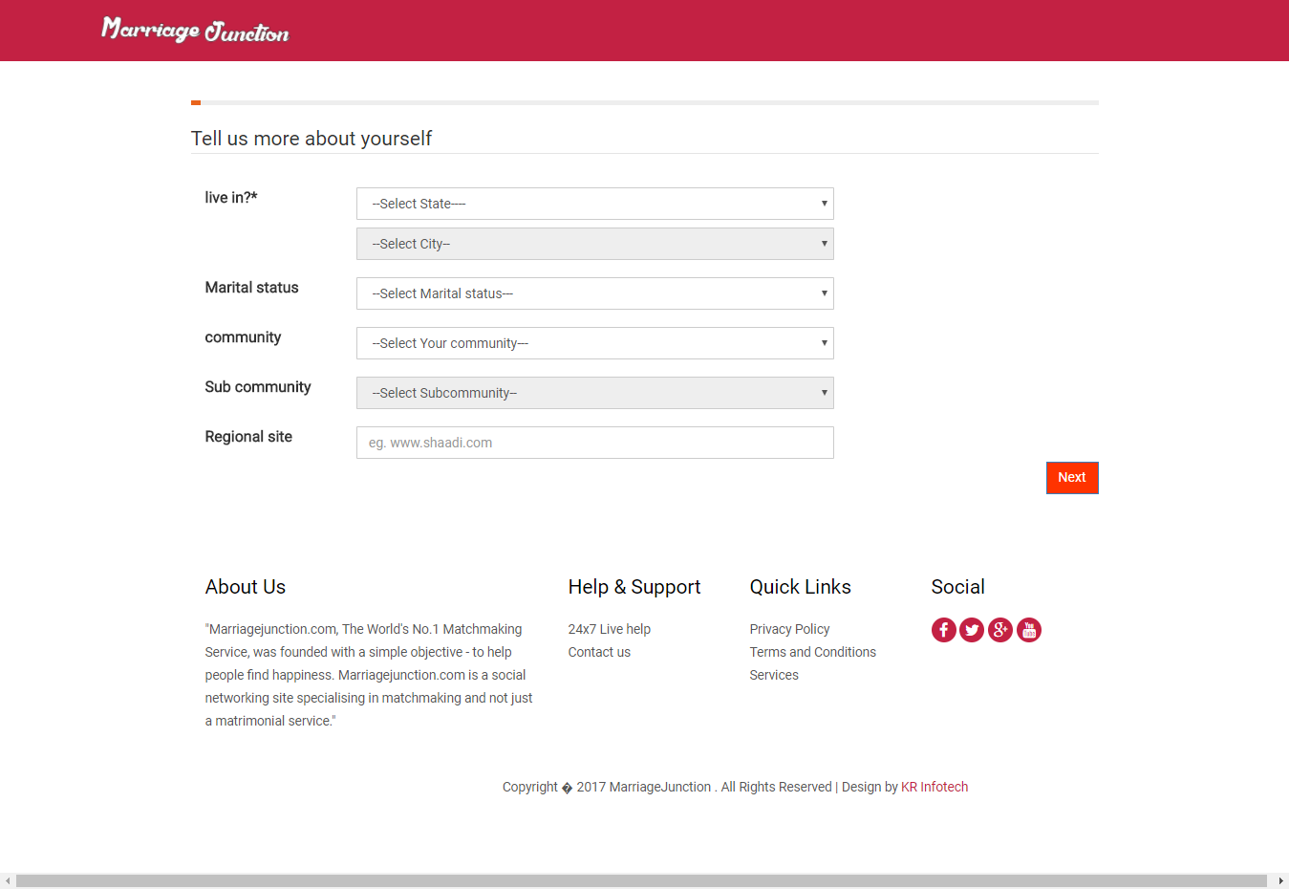

SMS Verification

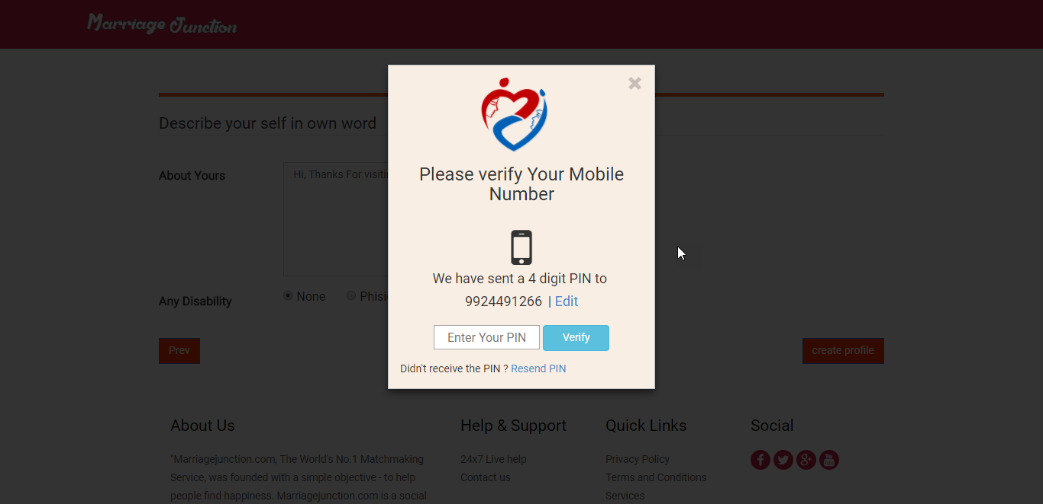

Profile Photo Upload

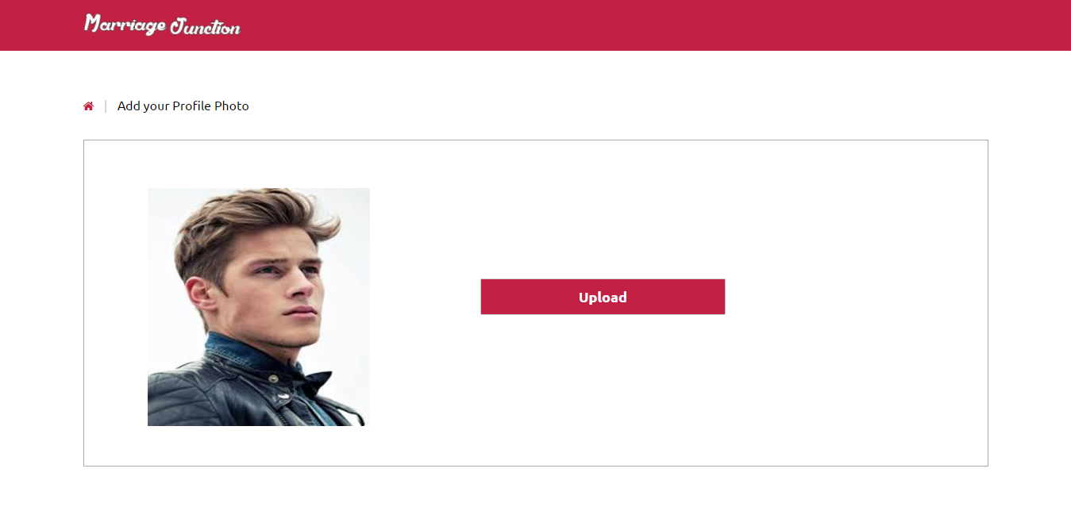

Change Password

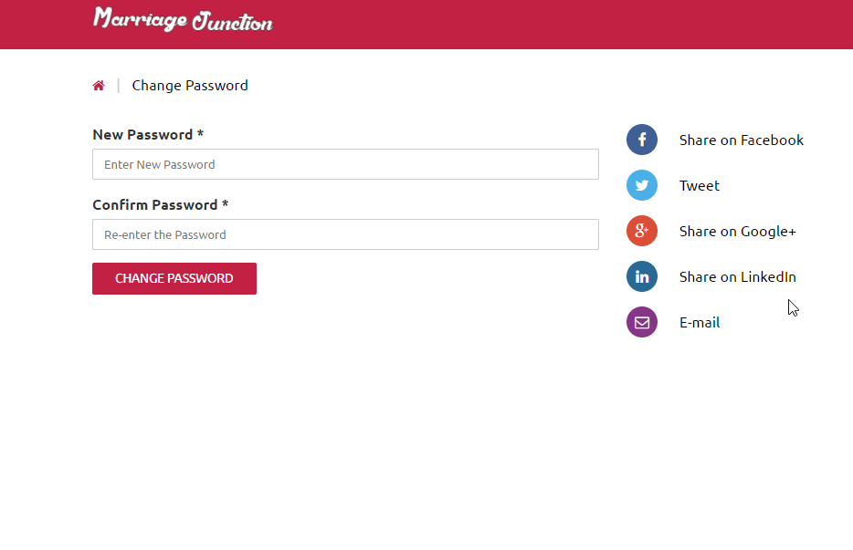

Live Chat Login Page(User)

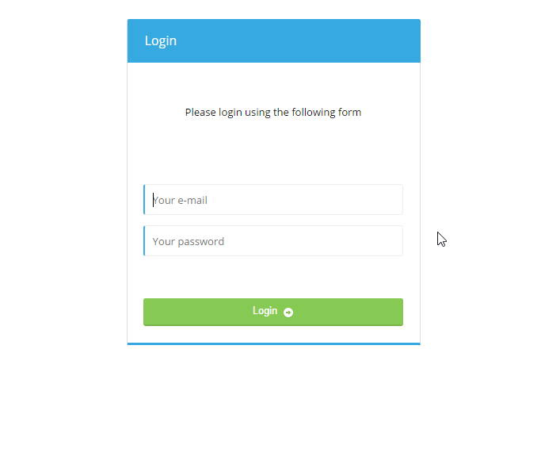

Live Chat With Admin

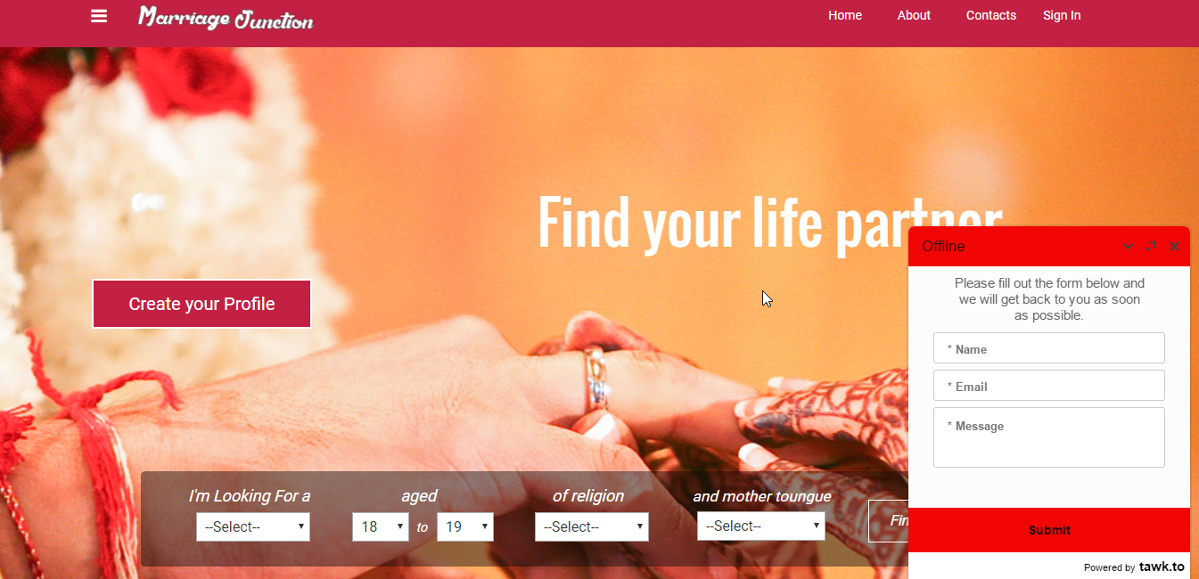

**7.4) OUTPUT DESIGN**

Admin Dashboard

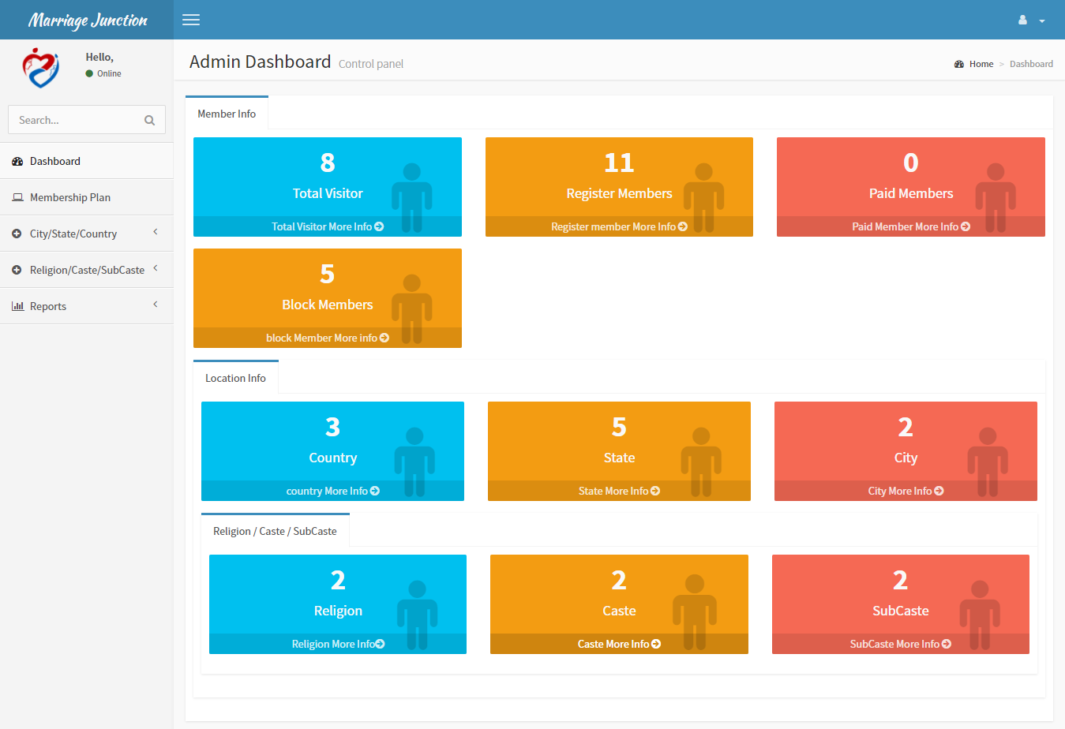

View Registred Members

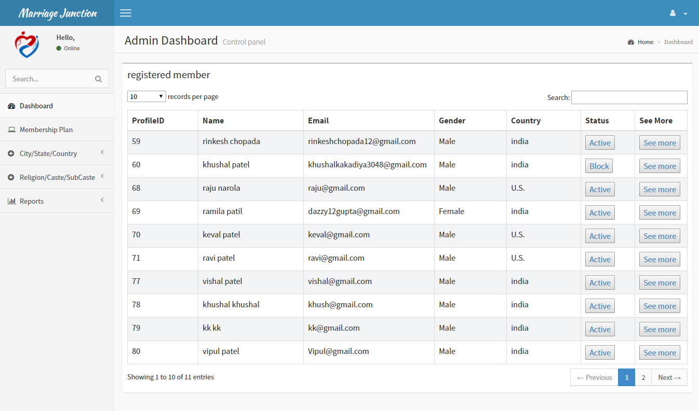

View Block Members

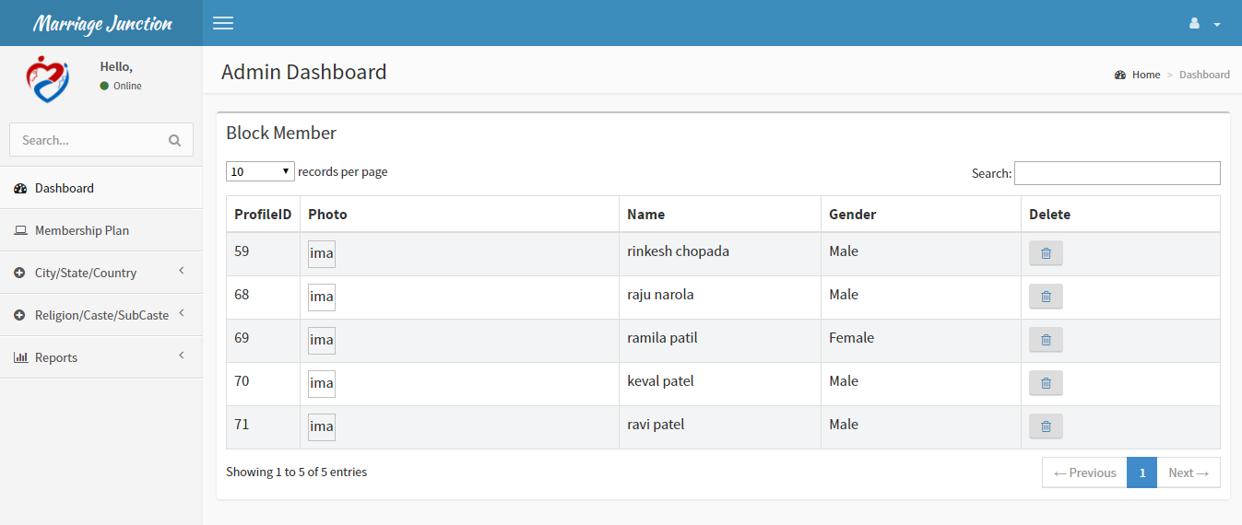

View Visitors

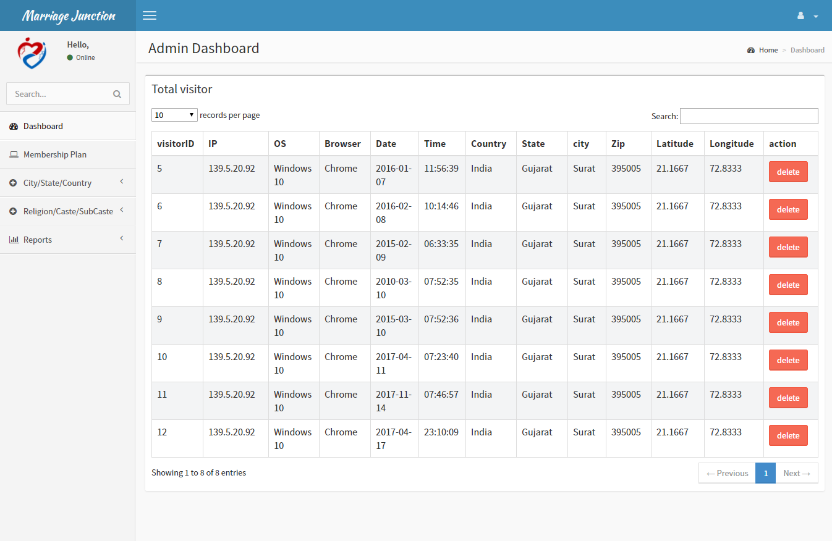

View Country Details

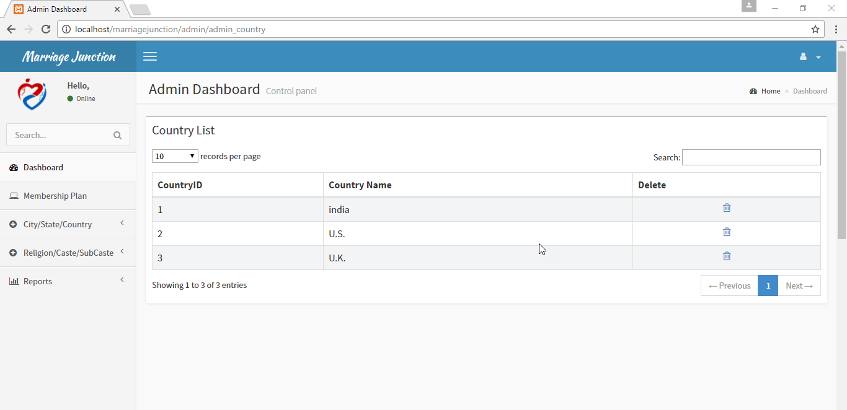

View Religion Details

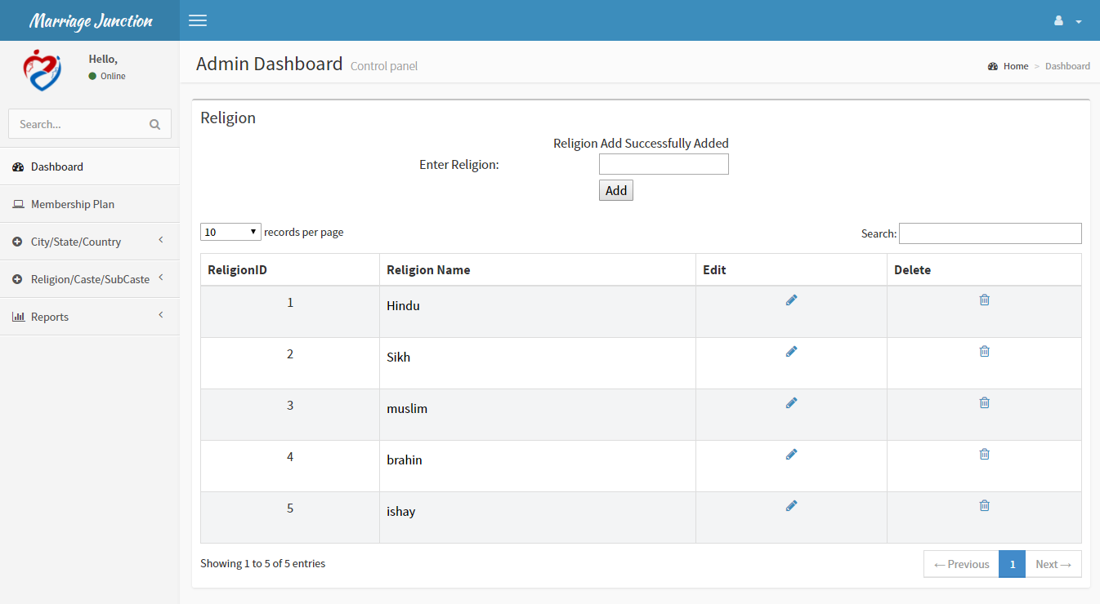

View Report For Monthly Visitor(Pie Chart)

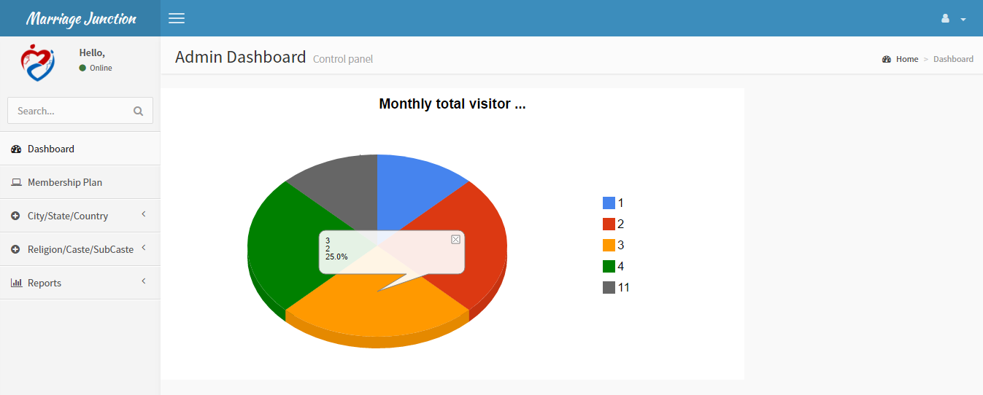

View Report Of Top Profile Views(Column Chart)

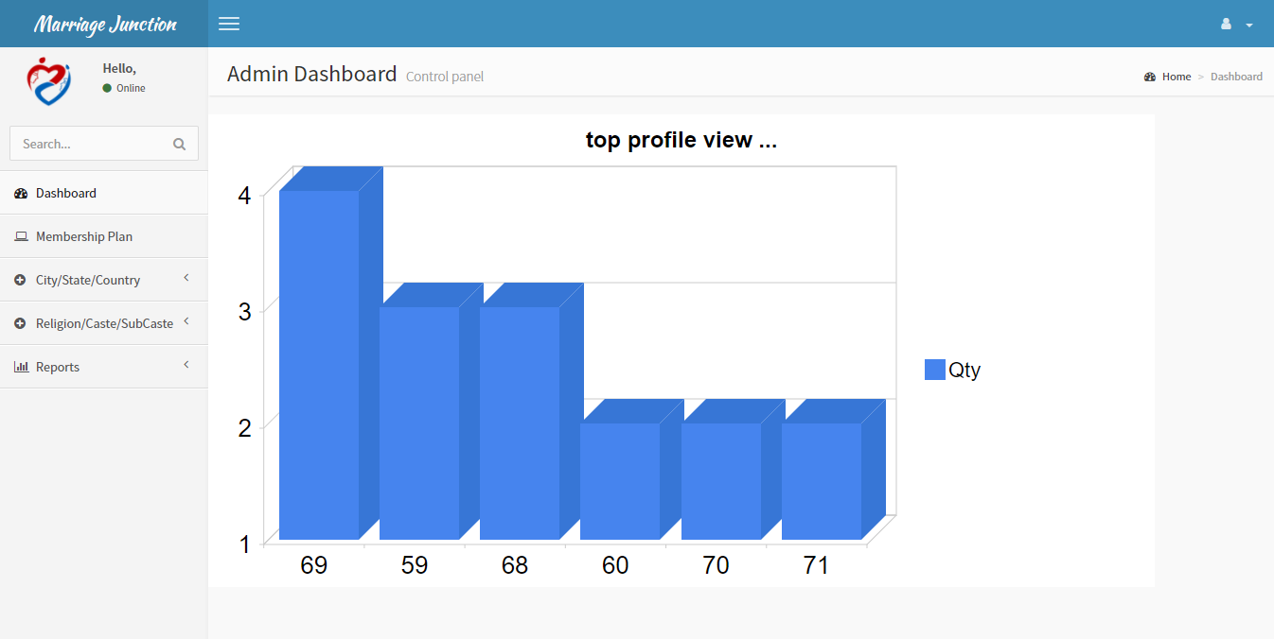

User Profile

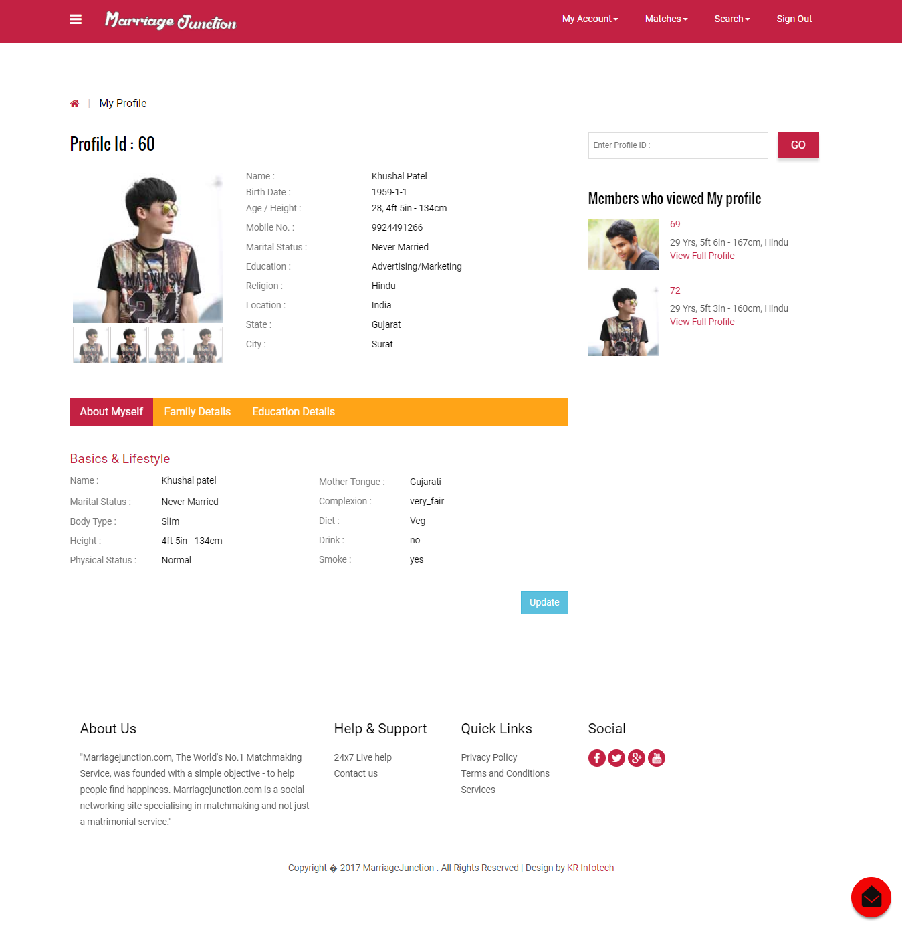

New Matches Page

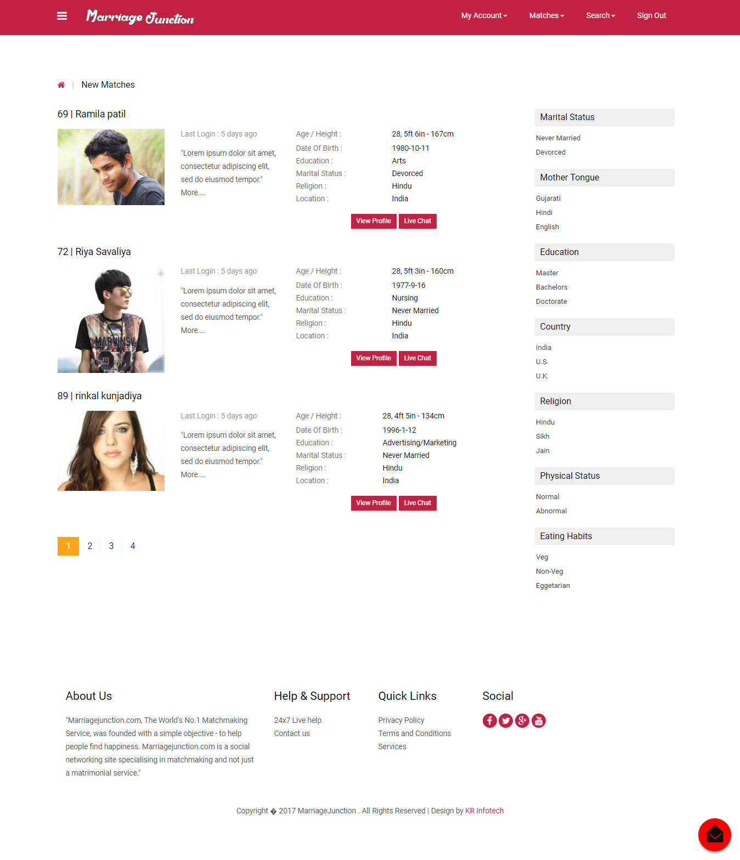

Regular Search Page

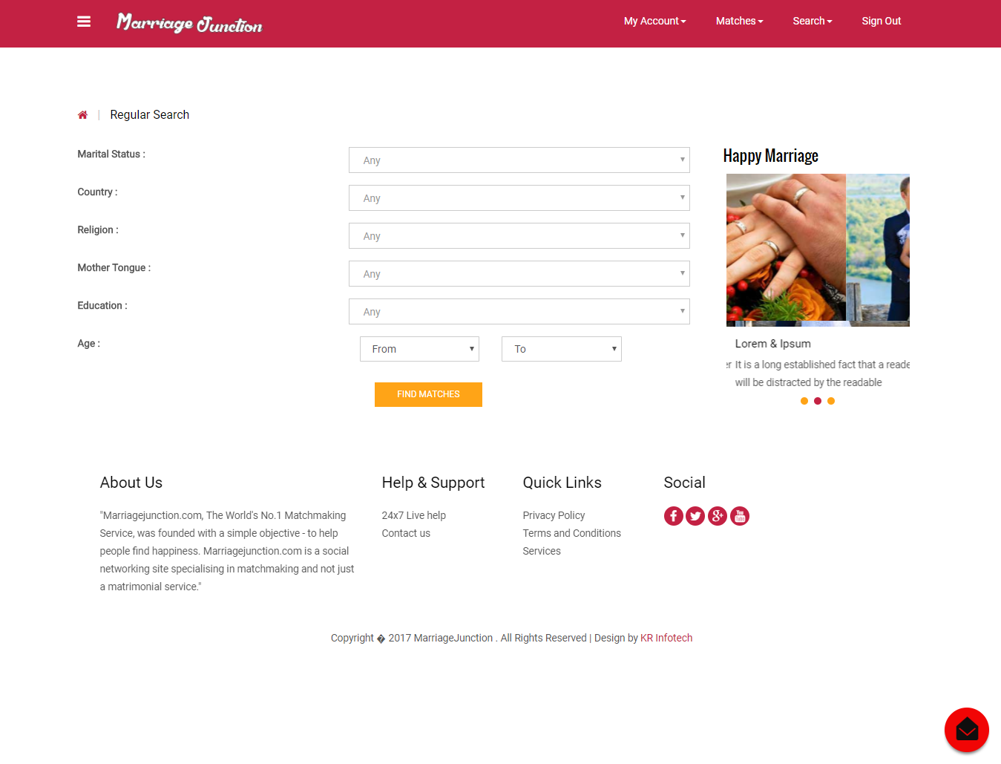

Search By Profile ID

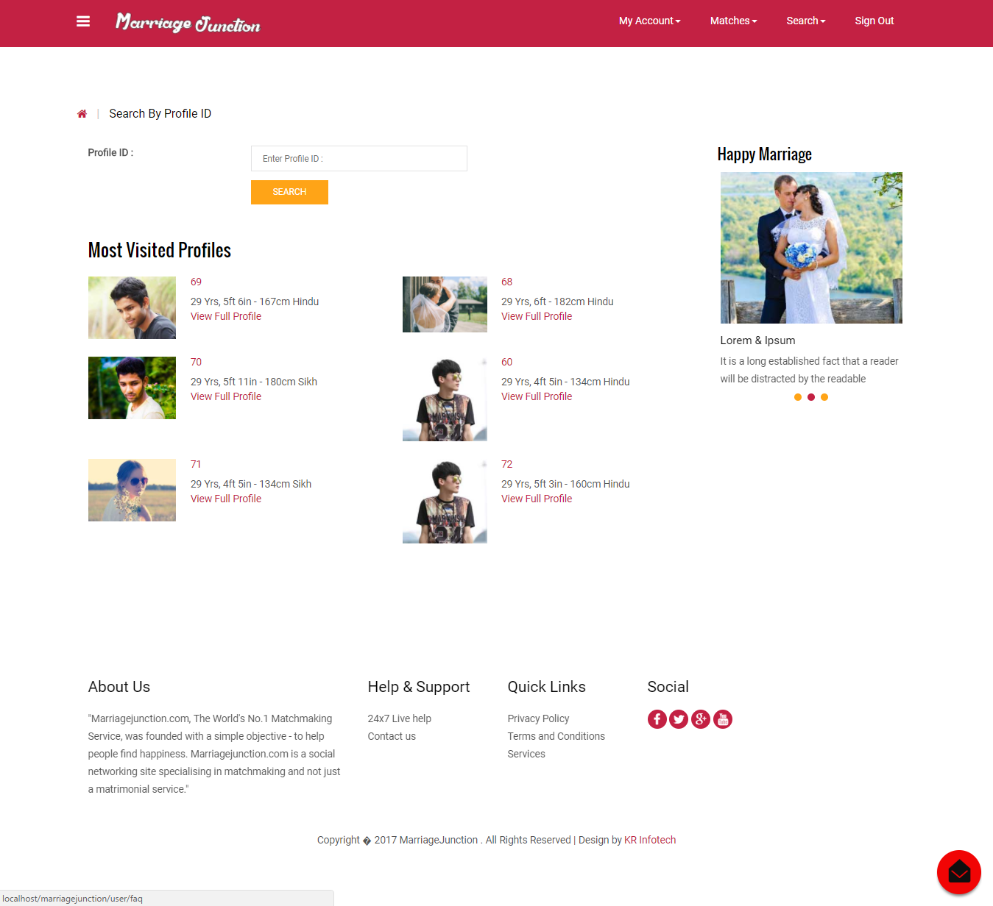

Who View My Profile

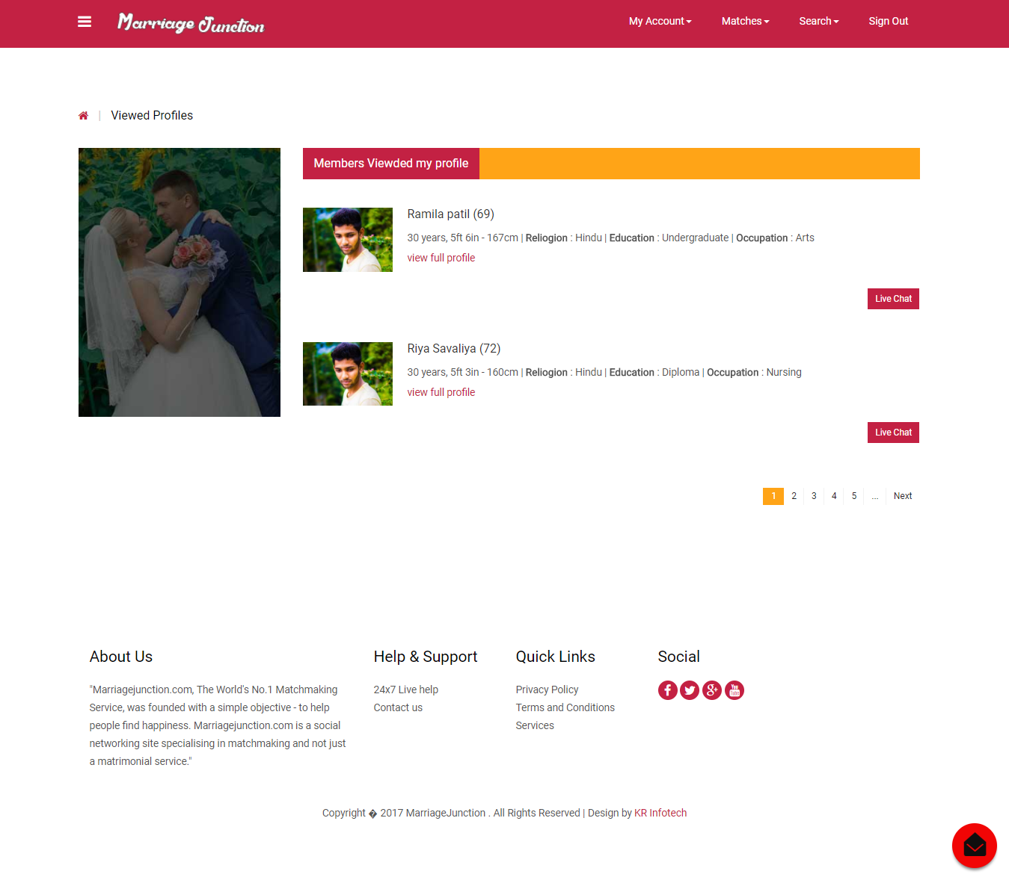

Live Chat Panel

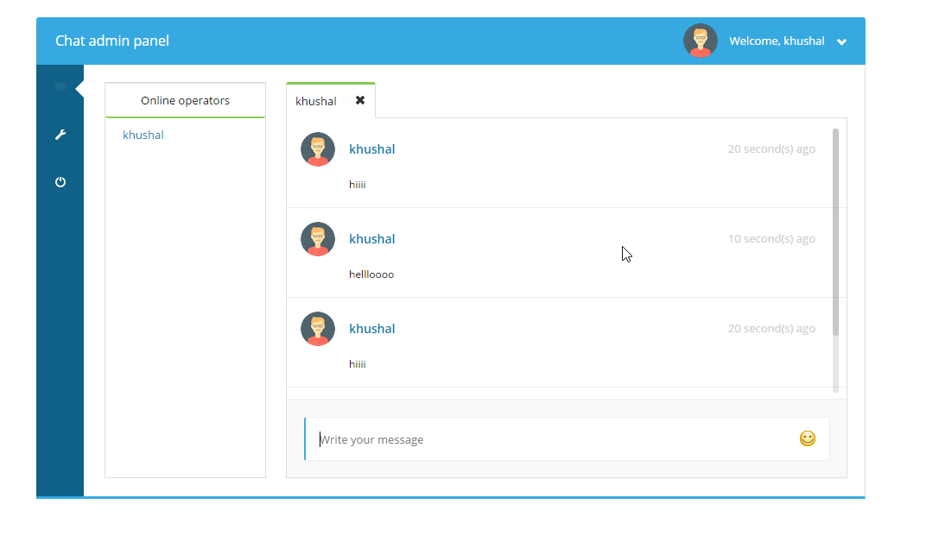

**8) SOFTWARE TESTING**

* Software Testing

Software Testing Is A Critical Element Of Software Quality Assurance And Represents The Ultimate Review Of Specification Design And Coding. Testing Is An Exposure Of A System To Trial Input To See Whether It Produces Correct Output. Testing Cannot Be Determined Whether Software Meets User’s Needs, Only Whether It Appears To Confirm To Requirements. Testing Can Show That A System Is Free Of Errors, Only That It Contains Error. Testing Finds Errors, It Does Not Correct Errors. Software Success Is A Quality Product, On Time And Within Cost. Though Testing Can Revel Critical (Costly) Mistakes. Testing Should Therefore,

1. Validate Performance.
2. Detects Errors.
3. Identify Inconsistencies.

* Test Objective

There Is Strong Evidence That Effective Requirement Management Leads To Overall Project Cost Savings. The Three Primary Reasons For This Are:

* Requirement Errors Typically Cost Well Over 10 Times More To Repair Than Other Errors.
* Requirement Errors Typically Comprise Over 40% Of All Errors In A Software Project.
* Small Reduction In The Number Of Requirement Errors Pays Big Dividends In Avoided Rework Costs And Schedule Delays.

The Testing Procedure Should Care For All Of These, As Well As, In Order To Attain A Flawless, Error-Free And Efficient Functioning System; Too, Software Testing Is An Important Phase Of Any Software Development Life Cycle. The System Presented Here Is Titled As “Coderszone.Com”. Various Reports And Data Used For The Same Are The Core Of The System. The Testing, Therefore, Becomes Important In Order To Maintain The Cost As Well As Improve Performance And Consistency. The Testing Procedure For The System Has Been Divided In To Various Parts Ranging For Single Unit Testing To Entire System Testing.

* Test Planning
  + Test Planning Evolves The Following Steps:
  + Estimate The Size And Cost Of The Testing Efforts.
  + May Allocate Test Resources.
  + Schedule Test Activities In Accord With Other Development Work.
  + Generate Test Cases.
* Generating Test Cases
  + A Test Case Is A Unit Of Testing Activity. Test Cases Have Three Parts:
  + Goal*-* The Aspect Of The System Being Tested.
  + Input And System State- Data Provided To The System Under Stated Conditions.
  + Expected Behavior-The Output Or Action The System Should Take According To These Requirements.
* Test Case Selection

The Presented System “Coderszone.Com” Is Tested Using White-Box Testing Which Is Based On The Internal Structure Of The System, May Also Called As Testing To Code, Path-Oriented Testing, Or Logical-Driven Testing. A Common Goal Of White-Box Testing Is To Have A Test Case To Exercise Every Path Through A Program. This May Become Exhaustive.

* White Box Testing Case Selection

Because Exhaustive White-Box Testing Is Infeasible, Test Or Code Coverage Metrics Are Used To Select Test Cases, Which Measure The Fraction Of Code Exercised By Test Cases. Test Cases Are Selected To Achieve Target Test Coverage Levels.

* Test Coverage Metrics
* Statement Coverage : The Fraction Of Statements Executed At Least Once Is Running A Collection Of Test Cases.
* Branch Coverage : The Fraction Of Total Branch Directions That Have Been Taken At Least Once In Running A Collection Of Test Cases,
* Path Coverage : The Fraction Of Paths Taken At Least Once In Running A Collection Of Test Cases, Where A “Path” Is Defined In Some Way To Limit The Totals Of Feasible Collection
* Unit Testing

The Presented System Is Tested First Using Unit Testing. Unit Testing Is Test Of Code Written By A Single Programmer. A Unit Is A Portion Of A System Implemented By A Single Programmer. Unit Testing Is Exercising A Unit In Isolation From The Rest Of The System. The System, Then, Is Tested Using Integrating Testing.

* Integration Testing
* Top-Down : Combine, Test And Debug Top-Leveled Routines That Become The Integration Test That Harms For Lower-Level Units.
* Bottom-Up : Combine, Test Low-Level Routines Into Progressively Larger Modules And Subsystems.
* Sandwich : Mainly top-down with bottom-up integration and testing applied to certain widely used components.
* Failure And Recovery

The system is tested using sandwich testing so as it has integrated advantages of both the top-down integration as well as bottom-up integration testing.

* Advantages Of Using Top-Down Integration
* The top levels of the system are tested the most.
* Distributes integration and testing throughout the coding phase.
* Tends to make bug location easier.
* Minimizes test harms creation.
* Advantages Of Using Bottom-Up Integration

Works well early in the integration process; thorough testing is possible and bugs are easy to be found.

* Test Completion
* White-box test coverage targets are met.
* Rate of error discovery reduced the target value.
* Measured reliability of the system achieves its target value.

**9) LIMITATION AND ENHANCEMENT**

* Limitation
* User must have been registered to find his/her life partner.
* We are not providing profile photo scanning facility so sometimes some people do mischief with other users.
* Future Enhancement

* We Are Going To Enhance The Paypal System For Online Transaction So That Customer Has No Worried About The Payment System He Or She Has Just Information About The Credit Card And Electronic Payment Cards.
* When will found any matches at that time notify to user his/her match details by SMS and Email.

* Profile photo and User Identity Proof scanning.
* Photo gallery.

**10) REFERENCES**

* References
  + Websites :
* <http://www.phptutorial.com>
* <http://www.easyphpwebsites.com>
* [http://www.bestphpwebsites.com](http://www.bestphpwebsites.com/)
* <http://www.google.com>
* <http://www.w3schools.com>